

**Customer Churn**

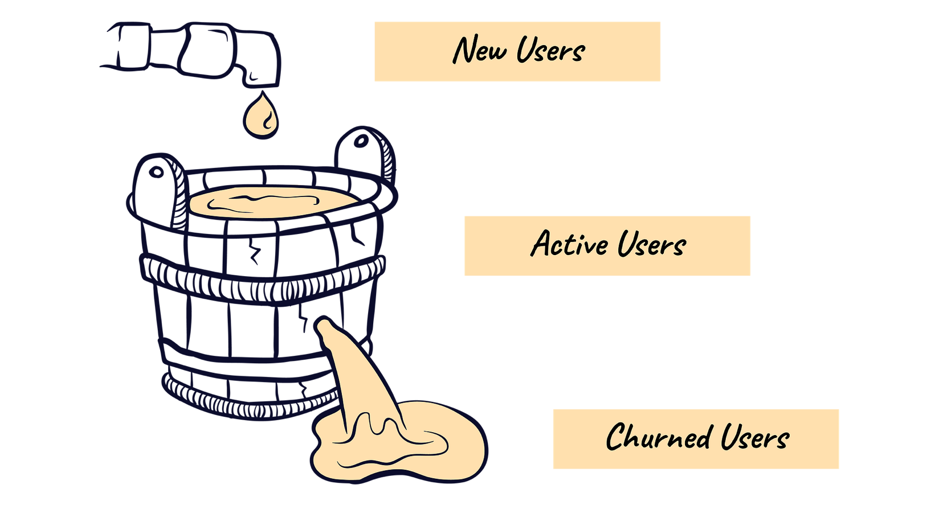

**Capstone Project**

**Final Report**



**Prepared by Dhruv Dosad**

**Table of Contents**

|  |  |
| --- | --- |
| Table of Contents | 1 |
| List of Figures | 2 |
| List of Tables | 2 |
| **1. Introduction of the business problem** | **4** |
| Brief introduction about the problem statement | 4 |
| Need of the study/project | 4 |
| **2. EDA and Business Implication** | **4** |
| Univariate analysis | 8 |
| Bivariate & Multi variate analysis | 15 |
| Impacting of Analysis on the business | 23 |
| visual and non-visual understanding of the data | 23 |
| **3. Data Cleaning and Pre-processing** | **24** |
| Approach used for identifying and treating missing values and outlier treatment | 24 |
| Need for variable transformation | 25 |
| Variables removed or added and why | 26 |
| **4. Model building** | 28 |
| Clear on why was a particular model(s) chosen. | 30 |
| Effort to improve model performance | 30 |
| **5. Model validation** | 30 |
| How was the model validated? | 30 |
| **6. Final interpretation / recommendation** | 34 |
| Detailed recommendations for the management/client based on the analysis done. | 35 |

List Of Tables

|  |  |
| --- | --- |
| Table | Page No |
| Table 1.1 Sample of the dataset | 5 |
| Table 1.2 Information of the dataset | 5 |
| Table 1.3 Descriptive Statistics of the Numerical Variable | 6 |
| Table 1.4 Descriptive Statistics of the Categorical Variable | 7 |
| Table 1.5 Missing values in dataset | 24 |
| Table 1.6 Encoded categorical variables | 25 |
| Table 1.7 Scaled variables | 26 |
| Table 1.8 Model comparison Test | 30 |
| Table 1.9 Model comparison train | 30 |
| Table 1.10 Classification report SVM | 32 |

List Of Figures

|  |  |
| --- | --- |
| Figure | Page No |
| fig 1.1 Target variable distribution | 8 |
| fig 1.2 Univariate Analysis- Tenure | 8 |
| fig 1.3 Univariate Analysis- CC_Contacted_LY | 9 |
| fig 1.4 Univariate Analysis- rev_pre_month | 9 |
| fig 1.5 Univariate Analysis- rev_growth_yoy | 9 |
| fig 1.6 Univariate Analysis- coupon_used_for_payment | 10 |
| fig 1.7 Univariate Analysis- Day_Since_CC_connect | 10 |
| fig 1.8 Univariate Analysis- Cashback | 11 |
| fig 1.9 Univariate Analysis- City_tier | 11 |
| fig 1.10 Univariate Analysis- Payment | 12 |
| fig 1.11 Univariate Analysis- Gender | 12 |
| fig 1.12 Univariate Analysis- Service_Score | 12 |
| fig 1.13 Univariate Analysis- Account_User_count | 13 |
| fig 1.14 Univariate Analysis- Account_Segment | 13 |
| fig 1.15 Univariate Analysis- CC_Agent_Score | 14 |
| fig 1.16 Univariate Analysis- Marital Status | 14 |
| fig 1.17 Univariate Analysis- Complaint_LY | 15 |
| fig 1.18 Univariate Analysis- Login_device | 15 |
| fig 1.19 Bivariate Analysis- City_Tier with Churn | 16 |
| fig 1.20 Bivariate Analysis- Payment with Churn | 16 |
| fig 1.21 Bivariate Analysis- Payment with Churn | 17 |
| fig 1.22 Bivariate Analysis- Service_Score with Churn | 17 |
| fig 1.23 Bivariate Analysis- Account_user with Churn | 18 |
| fig 1.24 Bivariate Analysis- Account Segment with Churn | 18 |
| fig 1.25 Bivariate Analysis- CC_Agent_Score with Churn | 19 |
| fig 1.26 Bivariate Analysis- Marital Status with Churn | 19 |
| fig 1.27 Bivariate Analysis- Complain_ly with Churn | 20 |
| fig 1.28 Bivariate Analysis- Login Device with Churn | 20 |
| fig 1.29 Bivariate Analysis- Tenure with Churn | 20 |
| fig 1.30 Bivariate Analysis- CC_Contacted_LY with Churn | 21 |
| fig 1.31 Bivariate Analysis- rev_per_month with Churn | 21 |
| fig 1.32 Bivariate Analysis- rev_growth_yoy with Churn | 21 |
| fig 1.33 Bivariate Analysis- coupon_used_for_payment with Churn | 22 |
| fig 1.34 Bivariate Analysis - Day_Since_CC_connect with Churn | 22 |
| fig 1.35 Bivariate Analysis- cashback with Churn | 22 |
| fig 1.36 Correlation Matrix | 22 |
| fig 1.37 Pairplot | 23 |
| fig 1.38 Missing value Treatment | 24 |
| fig 1.39 Outliers in the data | 24 |
| fig 1.40 ROC-AUC Curve Train data | 31 |
| Fig 1.41 ROC-AUC Curve Test data | 31 |
| Fig 1.42 Confusion Matrix SVM | 32 |
| Fig 1.43 ROC-AUC Curve SVM | 33 |
| Fig 1.44 Feature Importance & Learning Curve SVM | 33 |

**Customer Churn**

#### ****1. Introduction****

#### ****problem statement:****

The problem at hand is developing a churn prediction model for a DTH service provider. The primary challenge faced by the company is retaining existing customers in a highly competitive market. Account churn, where one account can encompass multiple customers, poses a significant threat, as the loss of a single account can result in the attrition of several customers. The problem is to create a predictive model to identify potential churners and design segmented offers to retain them.

#### ****Why Is It Needed?:****

The need for this study or project arises from the company's requirement to address the critical issue of customer churn. Retaining customers is pivotal, and the company aims to achieve this by creating a model that can predict churn and provide tailored offers to potential churners. In this context, the project is essential for enhancing customer retention, staying competitive in the market, exploring revenue growth opportunities, and elevating the overall customer experience.

**Understanding business opportunity**

**The business opportunity lies in devising a sophisticated churn prediction model and formulating distinct campaign recommendations to combat churn effectively.**

**The potential benefits include strengthening customer loyalty, improving market competitiveness, unlocking revenue growth, and delivering an exceptional customer experience.**

**The project represents a unique business opportunity to align recommendations with strategic objectives, ensuring they don't inadvertently lead to losses for the company. It underscores the importance of creating offers that are both enticing to customers and financially viable for the business, presenting a balance between customer satisfaction and revenue assurance.**

**2. EDA AND BUSINESS IMPLICATION**

**a) Understanding how data was collected in terms of time, frequency and methodology**

#### **The data source and context are not explicitly detailed. It appears to be derived from a DTH (or Cable) service provider, potentially originating from historical records. The data column description indicates it as average of previous 12 months at any point in time. However, geographical coverage and data duration (Date/year) remain unspecified.**

**\* Refer appendix for data description**

#### ****b) Visual inspection of data (rows, columns, descriptive details)****

**About the dataset:**

The number of rows are **11260**

The number of columns (variables) are **19**

**Sample of the data**

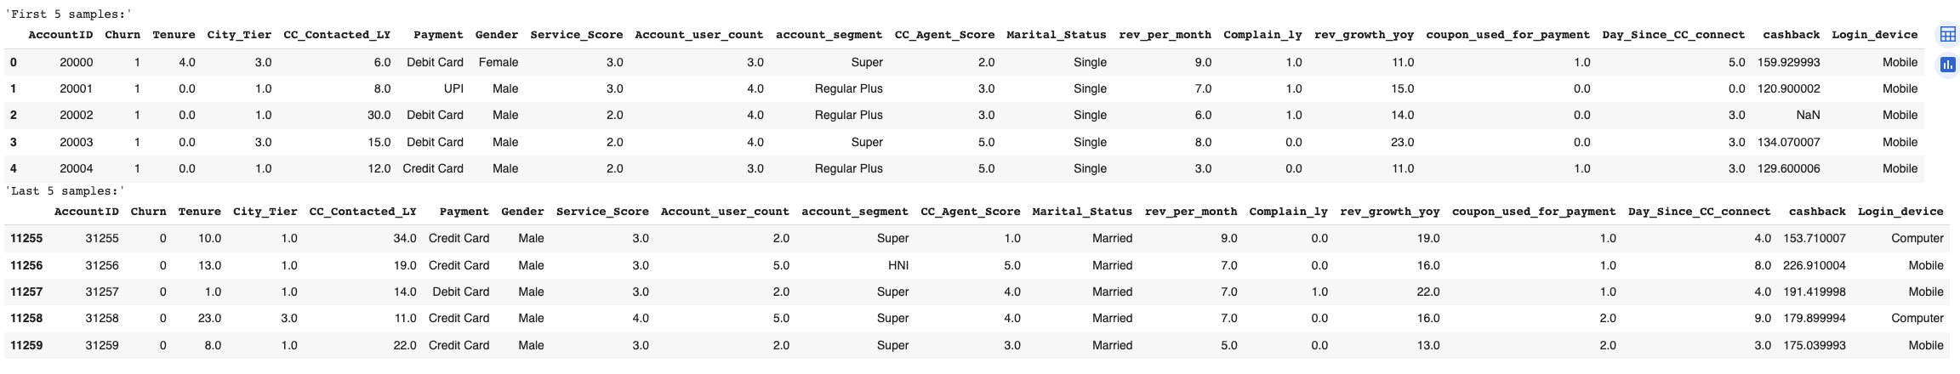

Table 1.1 Sample of the dataset

**Information about data**

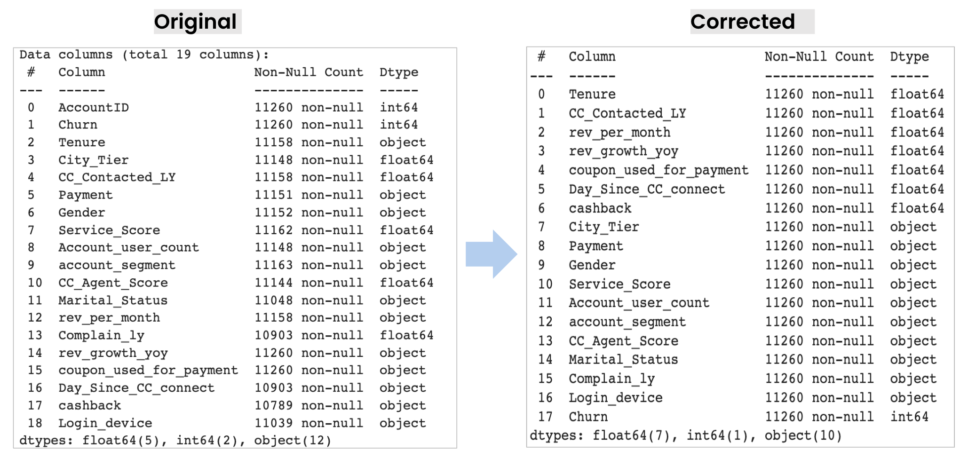

Table 1.2 Information of the dataset

The data needs preprocessing, handling missing values, and potential data type conversions.

* **Data Size and Completeness:** The dataset contains **11,260** **rows** and **19 columns**.
* **Target Variable (Churn):**  This is binary value, hence this is a **classification problem**
* **Categorical and Numerical Features:**
  + Mix of categorical and numerical features.
  + Incorrect labeling of some features as object or numerical, requiring data type correction.
  + Many columns are tagged as categorical but seem numeric, requiring data type correction.
* **Missing Values:** Missing values in several columns that need imputation.

### **Data Cleaning & Fixing Data Types**

### We identified unique values in each variable and fixed the values wherever we find data issues.

#### Categorical

* Lots of Numeric values seems to be tagged as Object, we checked their unique values & found unexpected values as shown below:

**NAN / Missing Values:** Below columns have NaN present:

* Tenure, City_Tier, CC_Contacted_LY, Payment, Gender, Service_Score, Account_user_count, account_segment,CC_Agent_Score,  Marital_Status, rev_per_month,  Complain_ly,  Day_Since_CC_connect, cashback, Login_device

**Unexpected Values:**

* **Tenure** (Unexpected values like **'#'**, high numerical values)
* **Account_user_count** (Unexpected value '**@'** alongside numerical counts)
* **Gender** (Inconsistent formatting with **'F'**and**'M'** alongside 'Female' and 'Male')
* **rev_per_month** (Unexpected values like ' **+** ', high numerical values)
* **rev_growth_yoy** (Unexpected values like ' **$** ' mixed with numerical values)
* **coupon_used_for_payment**(Unexpected values like '**#', '$'**, and '**\*'**  with numerical value)
* **Day_Since_CC_connect** (Unexpected values like **'$**' mixed with numerical values)
* **Login_device** (Unexpected value '**&&&&**' alongside 'Mobile' and 'Computer')

### **Approach to fix: We fixed these unexpected values by replacing them with nan(Null). The nan will be treated further using appropriate methods.**

#### Numerical Columns

#### We did not find any unexpected or negative values in Numerical columns except those which were tagged as Object and NAN values

#### There were many columns that were tagged as Numerical, we converted below Columns to categorical.

AccountID

City_Tier

Complain_ly

Service_Score

Account_user_count

CC_Agent_Score

### **Now, the data type has been fixed. We have 8 Numerical & 11 Categorical column**

### **Statistical Summary of dataset**

**Numerical columns**

### 

Table 1.3 Descriptive Statistics of the Numerical Variable

* **Average tenure**: ~11 months (Range: 0 to 99 months).
* **Customer care connect** (last year): ~17.87 times (Range: 4 to 132 times).
* **Average monthly revenue**: $6.36 (Range: $1.0 to $140.0).
* **Year-over-year revenue growth**: ~16.19% (Range: 4.0% to 28.0%).
* **Average coupons for payments**: ~1.79 (Range: 0 to 16 coupons).
* **Customer care contact** gap: ~4.63 days (Range: 0 to 47 days).
* **Average monthly cashback**: ~$196.24 (Range: $0.0 to $1997.0).

**Categorical columns**

### 

Table 1.4 Descriptive Statistics of the Categorical Variable

* **City_Tier**: 4 unique tiers; Most frequent: Tier 1.0 (7263 occurrences).
* **Payment**: 5 unique methods; Most frequent: "Debit Card" (4587 occurrences).
* **Gender**: 2 unique genders; Most frequent: "Male" (6704 occurrences).
* **Service_Score**: 7 unique scores; Most frequent: 3.0 (5490 occurrences).
* **Account User Count**: Mostly 4 users (4569 accounts); Range: 1 to 6 users.
* **Account Segment**: 5 unique segments; Most frequent: "Regular Plus" (4124 occurrences).
* **CC_Agent_Score**: 6 unique scores; Most frequent: 3.0 (3360 occurrences).
* **Marital_Status:** 3 unique statuses; Most frequent: "Married" (5860 occurrences).
* **Complain_ly:** 3 unique values; Most frequent: 0.0 (7792 occurrences).
* **Login_Device**: 2 unique devices; Most frequent: "Mobile" (7482 occurrences).

### **Please note: the above descriptive summary is of original dataset post cleaning, inclusive of nan & outliers, hence count may vary post treatment.**

### **Duplicate Values**

### **Total duplicates in the data are: 0**

**Univariate analysis**

**Target Variable**

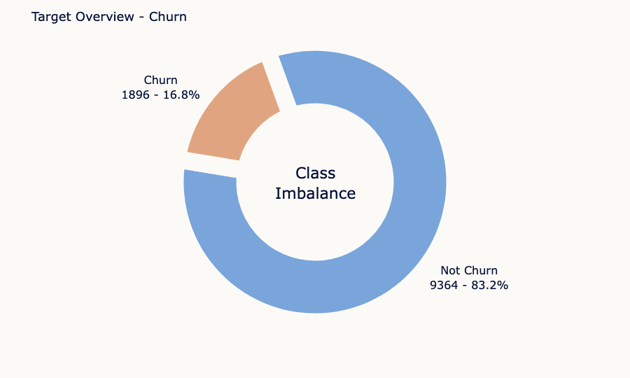

fig 1.1 Target variable distribution

* Churn Variable has 2 unique values , **1 which stands for Churned customer** and **0 for non churned customer**.
* We can clearly see the class Imbalance here. only 16.8% of the customers are churned.

**Numerical Variables**

**Tenure**:

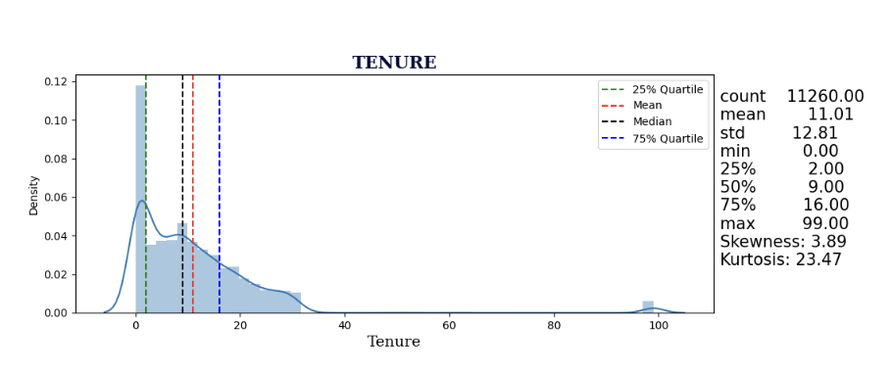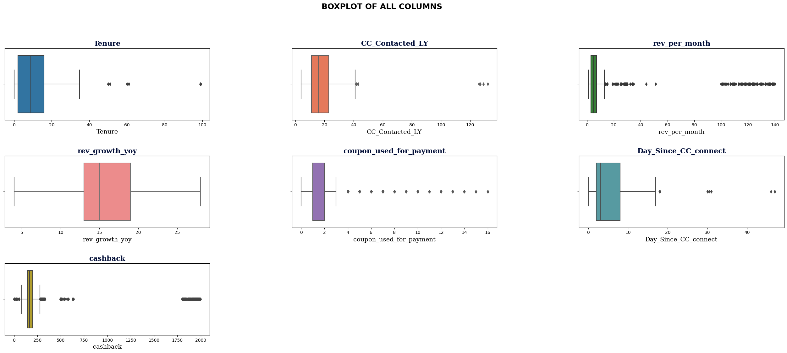

fig 1.2 Univariate Analysis- Tenure

* The **tenure** values have a **wide range** from **0 to 99 months**, indicating variability in customer loyalty.
* The distribution is **positively skewed (skewness 3.90),** suggesting that **more customers have shorter tenure.**
* There are **significant outliers** on the **higher end (kurtosis 23.37)**, which might represent long-term loyal customers or data anomalies.

**CC_Contacted_LY**:

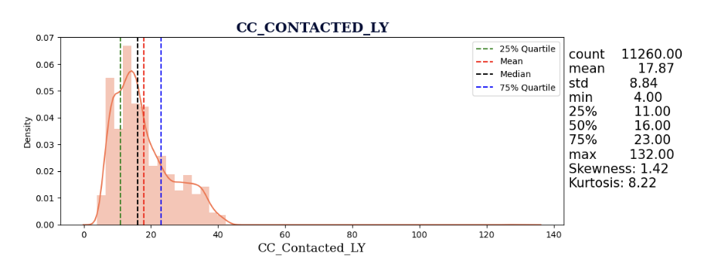

fig 1.3 Univariate Analysis- CC_Contacted_LY

* The number of **CC contacts in the last year** ranges from **4 to 132**, indicating variation in customer interactions.
* The distribution is **moderately positively skewed** (skewness 1.42). There are some **outliers with a higher number of contacts** (kurtosis 8.23), indicating potential high engagement customers or data anomalies.

**rev_per_month:**

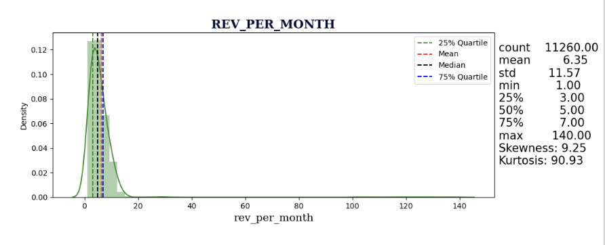

fig 1.4 Univariate Analysis- rev_pre_month

* **Monthly revenue** varies significantly, with values **ranging from 1 to 140.**
* The distribution is **highly positively skewed** (skewness 9.09), indicating that **most customers generate lower revenue.**
* There are many **extreme outliers (kurtosis 86.96),** potentially representing high-revenue customers or data anomalies.

**rev_growth_yoy:**

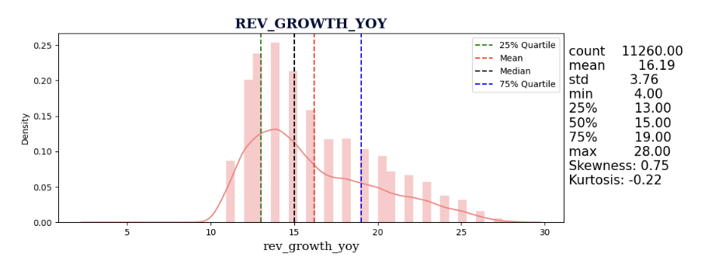

fig 1.5 Univariate Analysis- rev_growth_yoy

* Year-over-year revenue growth percentages range from 4% to 28%.
* The distribution is moderately positively skewed (skewness 0.75), suggesting steady growth rates.
* The kurtosis value is close to zero (kurtosis -0.22), indicating a distribution with lighter tails and fewer outliers.

**coupon_used_for_payment:**

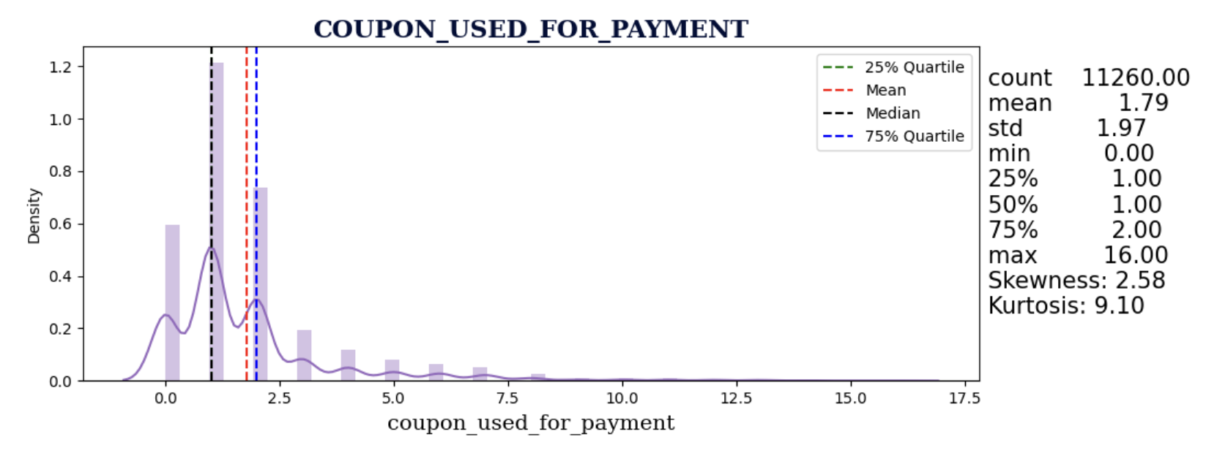

fig 1.6 Univariate Analysis- coupon_used_for_payment

* Most customers use 1 to 2 coupons for payments, with a range of 0 to 16.
* The distribution is positively skewed (skewness 2.58), indicating that a significant portion of customers uses coupons for payment.
* The kurtosis value is relatively high (kurtosis 9.10), suggesting a distribution with some outliers related to coupon usage.

**Day_Since_CC_connect:**

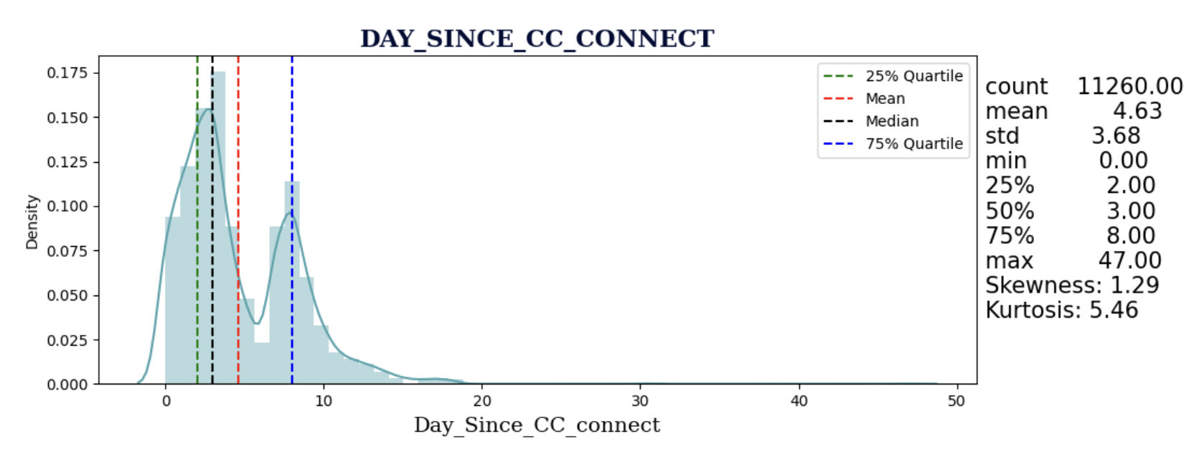

fig 1.7 Univariate Analysis- Day_Since_CC_connect

* The **number of days since the last customer care connect** spans from **0 to 47 days.**
* The distribution is **positively skewed** (skewness 1.27), indicating that most customers recently connected. **Around 50% of the user have not connected since 3 days or more**.
* The kurtosis value is 5.33, suggesting a distribution with **some customers having longer periods since the last connect.**

**cashback:**

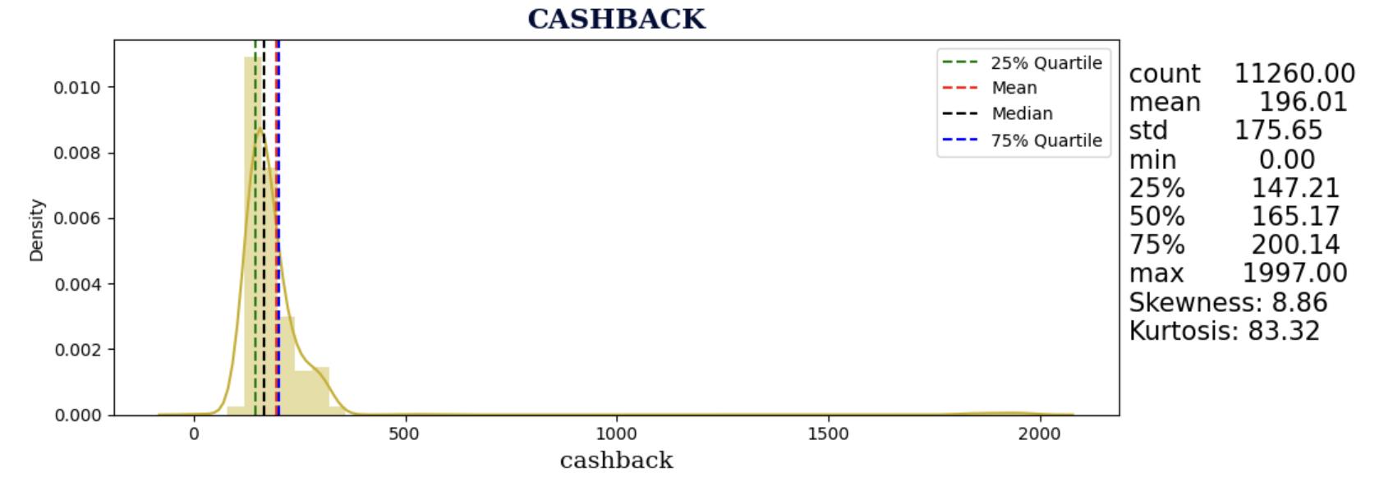

fig 1.8 Univariate Analysis- Cashback

* **Cashback** values vary widely from **0 to 1997.**
* The **distribution** is highly **positively skewed** (skewness 8.77), indicating that **most customers receive lower cashback amounts**.
* There are numerous **extreme outliers** (kurtosis 81.11), which could represent customers with **exceptionally high cashback or anomalies in the data**.

**Categorical Variables**

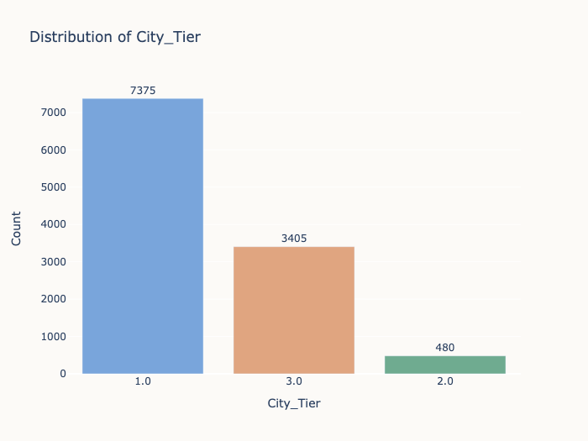 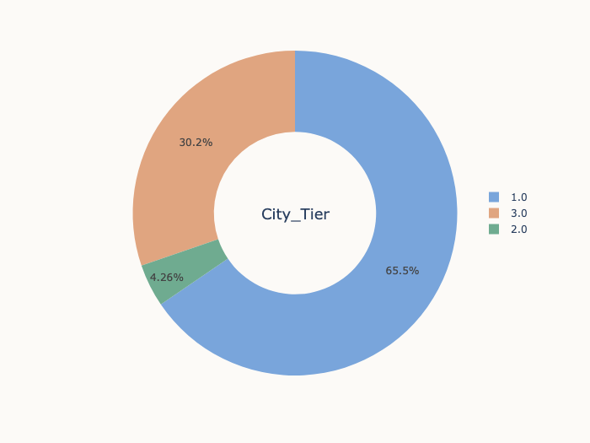

fig 1.9 Univariate Analysis- City_tier

* Approximately **65.50%** of customers are in **City Tier 1** while around **30.24%** of customers are in **City Tier 3.**
* The customers decreases with tiers, least customers are from lower tier cities.

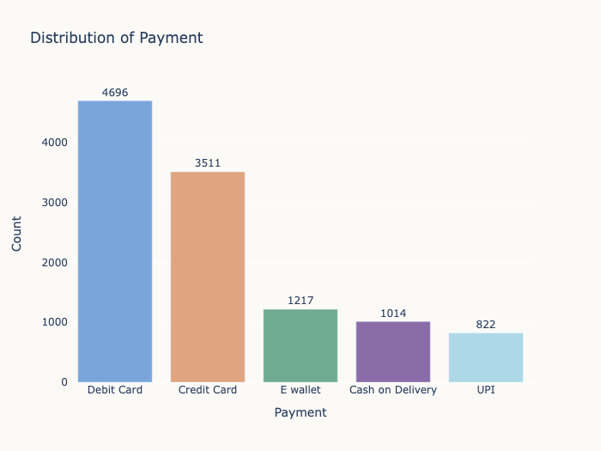 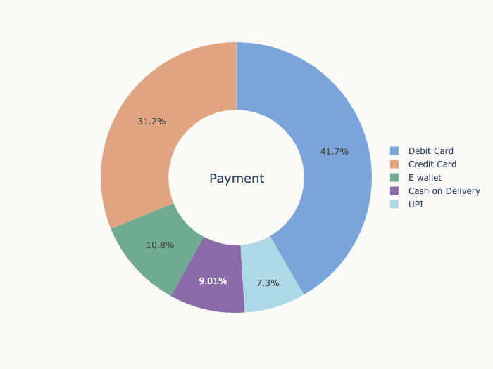

fig 1.10 Univariate Analysis- Payment

* The data suggests that most customers **prefer** "**Debit Card"(41.71%)** and **"Credit Card"(31.18%)** as **payment** **method**

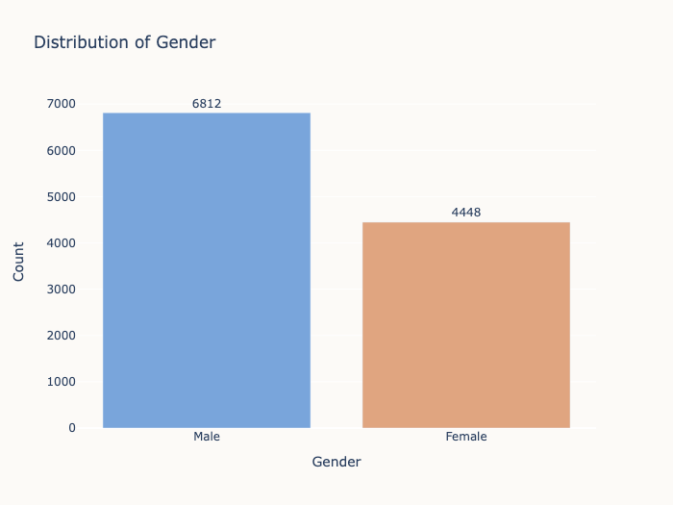 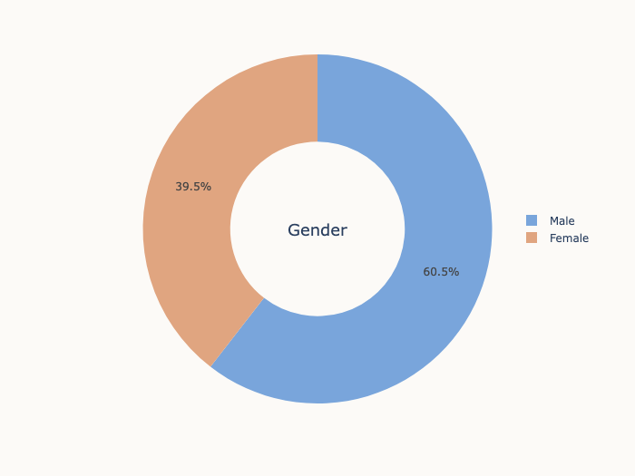

fig 1.11 Univariate Analysis- Gender

* **60.50%** of customers are **male**(Majority)

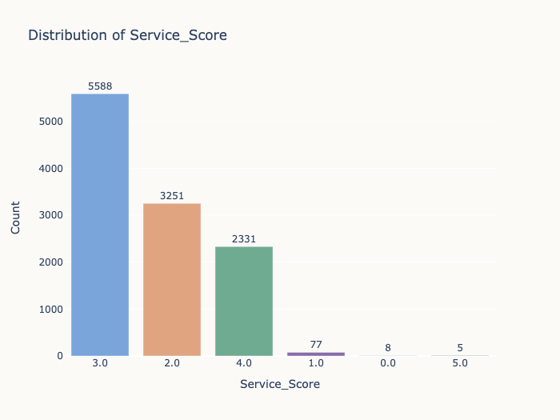 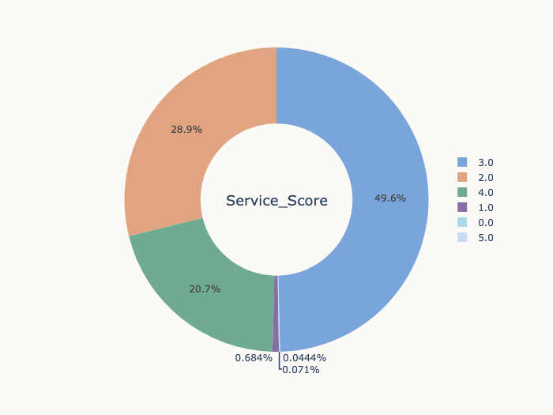

fig 1.12 Univariate Analysis- Service_Score

* A significant portion of customers have "**Service_Score" of 3.0 (49.63%)** suggesting customers are relatively **neutral with the services**.
* There are only **5 (0.071%) users** who are **highly satisfied** & **20.7% just satisfied**, which indicates **need of improvement in services**.

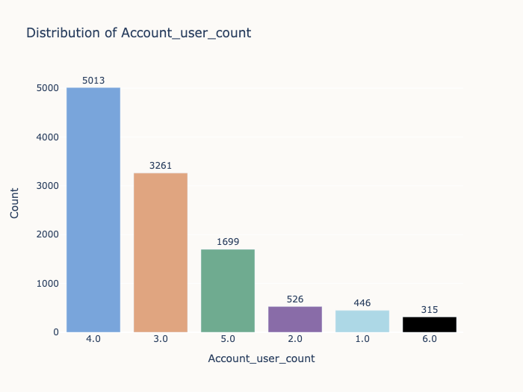 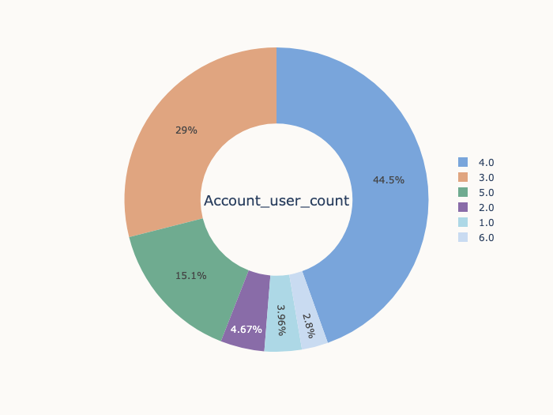

fig 1.13 Univariate Analysis- Account_User_count

* Most customers have **3 to 4** **account users**, with a range of 1 to 6 users.

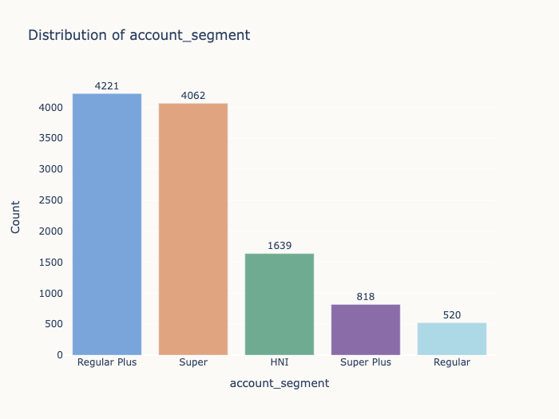 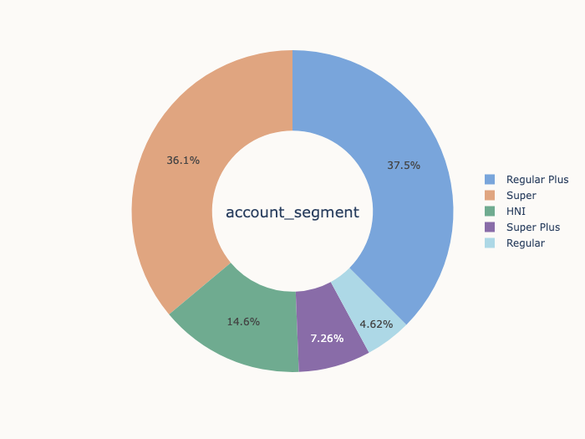

fig 1.14 Univariate Analysis- Account_Segment

* "**Regular Plus" and "Super**" are the most common account segments, making up **37.49% and 36.07%** of the customer base, respectively.

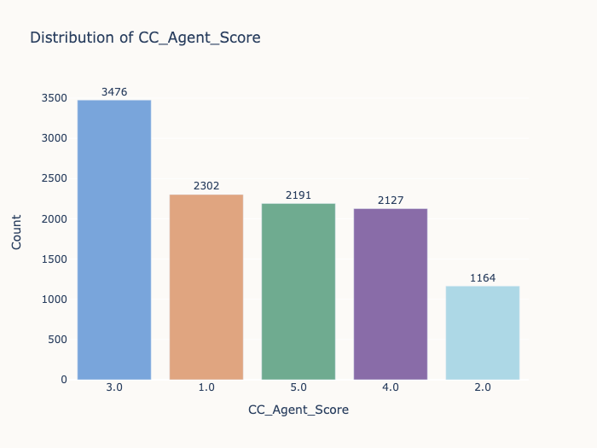 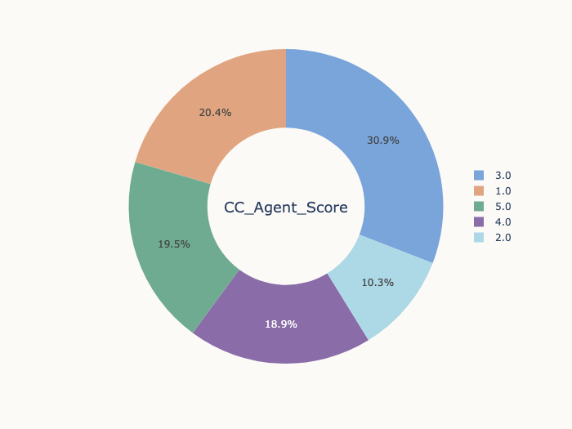

fig 1.15 Univariate Analysis- CC_Agent_Score

* **38.35%** having **customer care score 4 & 5** suggesting a ratio **of Satisfied users with customer care** while **30.78% having score 1 & 2** suggesting **relatively high dissatisfaction**

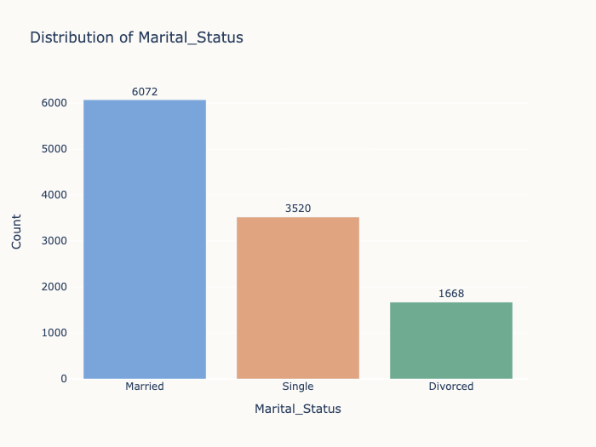 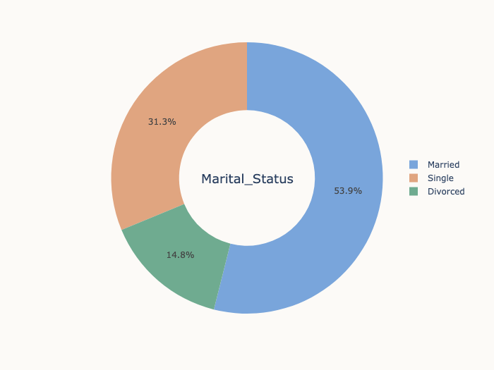

fig 1.16 Univariate Analysis- Marital Status

* **53.9%** of the subscribers are **married** while **31.3% are single.**

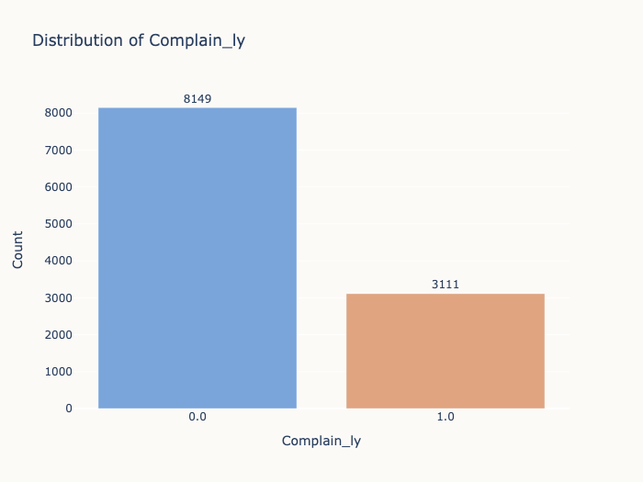 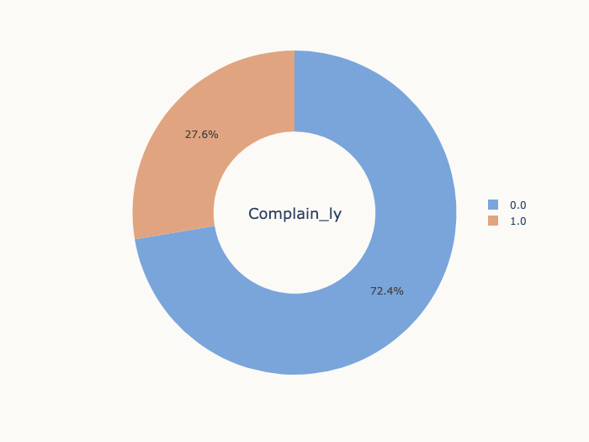

fig 1.17 Univariate Analysis- Complaint_LY

* Most customers **(72.37%)** **did not file** **any complaints** in the last year which indicates a **good sign of less customers facing issues**.

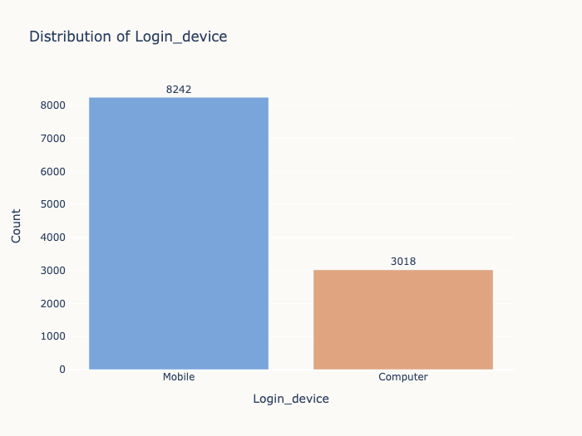 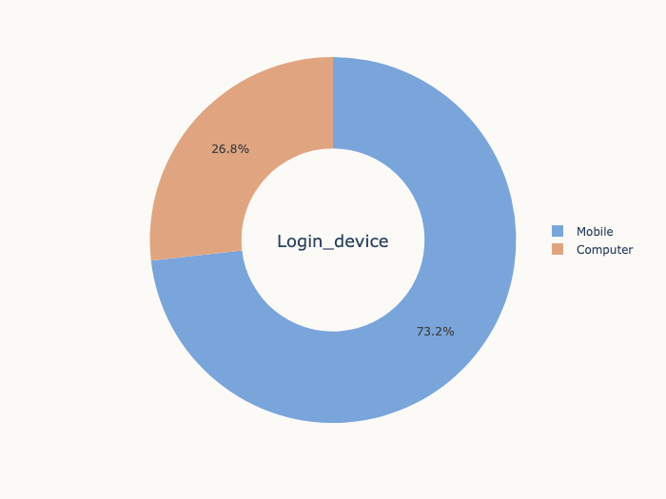

fig 1.18 Univariate Analysis- Login_device

* A **large portion** of customers use **mobile devices(73.20%) for login.**

#### ****Bivariate & Multivariate analysis****

**City_Tier:**

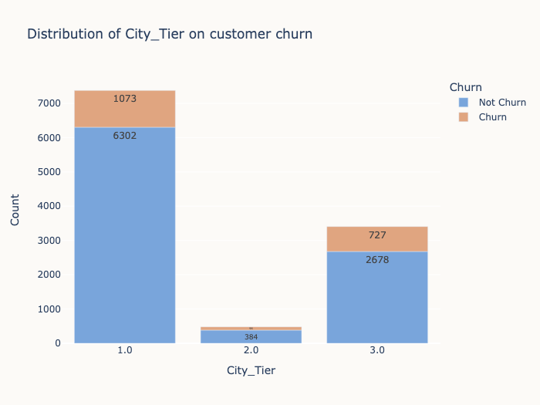 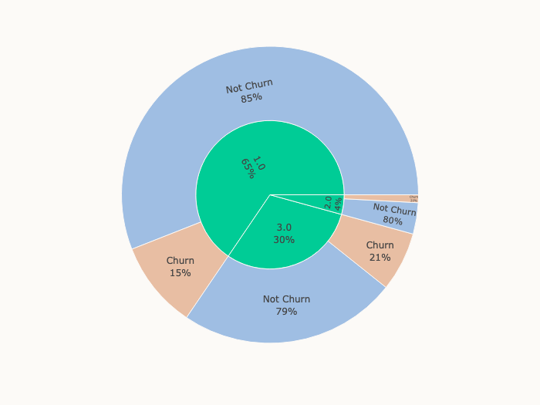

fig 1.19 Bivariate Analysis- City_Tier with Churn

* **City_Tier 1** has the **highest customer base**.
* Churn rate is relatively higher in **City_Tier 3 (21.3%)** compared to other City_Tiers.
* This might be either due to higher cost for tier 3 cities or availability of regional/local contents.

**Payment:**

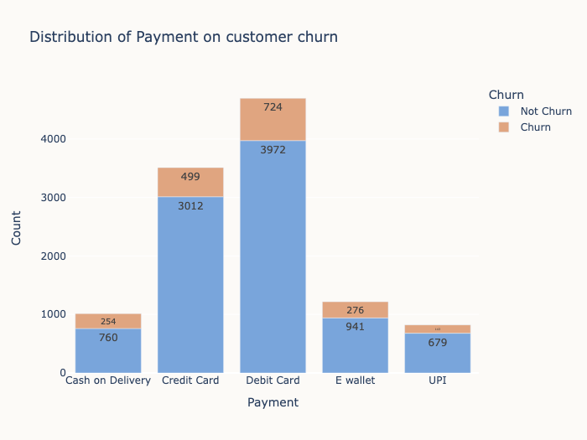 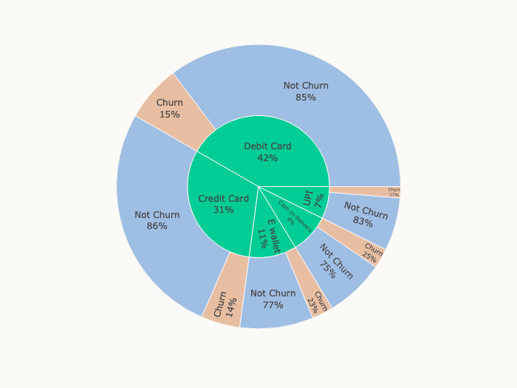

fig 1.20 Bivariate Analysis- Payment with Churn

* Customers who use 'Cash on Delivery' as their payment method have the highest churn rate (25.05%).
* 'Credit Card' and 'Debit Card' users have lower churn rates compared to 'Cash on Delivery' users.

**Gender:**

#### 

fig 1.21 Bivariate Analysis- Payment with Churn

* Churn is slightly **higher among 'Male'** customers **(~18%)** compared to **'Female' customers (15%).**

#### ****Service_Score****

#### 

fig 1.22 Bivariate Analysis- Service_Score with Churn

* A significant portion of customers have "**Service_Score" of 3.0 (49.6%)** suggesting customers are relatively **neutral with the services**.
* There are only **5 (0.071%) users** who are **highly satisfied** have 0 churn rate, while customers with score 0 and 1 also have 0% churn.
* On the other hand, customers with a **'Service_Score' of 2 and 3 & 4** have almost similar **churn rates (~17%),** indicates that the Churn rate is constant irrespectuve Service score.

**Account_User:**

#### 

fig 1.23 Bivariate Analysis- Account_user with Churn

* Most customers have 'Account_user_count' of **3 or 4**.
* Churn rate **increases** as **'Account_user_count' increases**.
* Customers with 'Account_user_count' of **6** have the **highest churn rate (34%),** followed by **5 having chrun rate of 22%.**

**Account Segment:**

#### 

fig 1.24 Bivariate Analysis- Account Segment with Churn

* **'Regular Plus'** account segment has the **highest churn rate (27.13%).**
* **'Regular' , 'Super Plus',** **'Super'** segments have the **lowest churn rates**.

**CC_Agent_Score:**

#### 

fig 1.25 Bivariate Analysis- CC_Agent_Score with Churn

* Customers with **'CC_Agent_Score' of 5.0** have the **highest churn rate (24%).**
* 'CC_Agent_Score' **of 1.0 and 2.0** have the **lowest churn** rates **(11% and 13% respectively**).
* **As 'CC_Agent_Score' increases**, the **churn rate also** **increases**, which is quite interesting to have a deep dive on why customer with higher Customer Care Agent score tends to churn which ideally should be opposite i.e. with higher CC agent score, less customers to churn.

**Marital Status:**

#### 

fig 1.26 Bivariate Analysis- Marital Status with Churn

* Customers with **'Single' marital status** have the **highest churn rate (27%),** which generally represents a younger population, might be due to unavailability of engaging contents or plans for younger/singles.
* **'Married'** customers have a **lower churn rate (12%).**
* **'Divorced'** customers have a **moderate churn rate (15%).**

**Complain_ly:**

#### 

fig 1.27 Bivariate Analysis- Complain_ly with Churn

* Customers who have **complained in the last year** ('Complain_ly' = 1.0) have a significantly **higher churn rate (31.76%).**
* Customers who **did not complain** ('Complain_ly' = 0.0) have a **lower churn rate (11.14%).**
* This indicates that the **issues with services leads to higher churn**, hence the complaints to be looked further to know the root cause & eliminate to reduce churn.

**Login Device:**

#### 

fig 1.28 Bivariate Analysis- Login Device with Churn

* Customers who use **'Computer'** as their **login device** have a **higher churn rate (19.78%).**
* Customers who use **'Mobile'** devices have a relatively **lower churn rate (15.76%).**
* This might indicate that users who prefer **login on the go or ease of login** tends to **churn lower**, the **company can promote app/mobile based logins to reduce churn.**

#### ****Distribution of Numerical Columns with Churn****

#### 

fig 1.29 Bivariate Analysis- Tenure with Churn

**Tenure:**

* Customers with **lower tenure (recent customers)** have a **higher churn rate.**
* Customers with **longer tenure (loyal customers)** have a **lower churn rate**.

#### 

fig 1.30 Bivariate Analysis- CC_Contacted_LY with Churn

**CC_Contacted_LY:**

* The **median connects** in last year is **higher** for customer who **churned** as compared to those who didn’t.

#### 

fig 1.31 Bivariate Analysis- rev_per_month with Churn

**rev_per_month:**

* Customers with **lower monthly revenue** tend to have a **higher churn rate.**
* Customers with **higher monthly revenue** have a **lower churn rate.**

#### 

fig 1.32 Bivariate Analysis- rev_growth_yoy with Churn

**rev_growth_yoy:**

* Customers with **lower year-over-year revenue** **growth** tend to have a **higher churn rate.**
* Customers with **higher year-over-year revenue growth** have a **lower churn rate.**

****

fig 1.33 Bivariate Analysis- coupon_used_for_payment with Churn

**coupon_used_for_payment:**

* Customers who use **fewer coupons** for payment tend to have a **higher churn rate**.
* Customers who use **more coupons** for payment have a **lower churn rate.**

****

fig 1.34 Bivariate Analysis - Day_Since_CC_connect with Churn

**Day_Since_CC_connect:**

* Customers with a **shorter time since the last contact** with customer care tend to **have a higher churn rate.**
* Customers with a **longer time since the last contact** with customer care have a **lower churn rate.**

fig 1.35 Bivariate Analysis- cashback with Churn

**cashback:**

* Customers with **lower cashback** **amounts** tend to have a **higher churn rate.**
* Customers with **higher cashback amounts** have a **lower churn rate**.

#### ****Correlation Heatmap****

#### 

fig 1.37 Correlation Matrix

**Pairplot**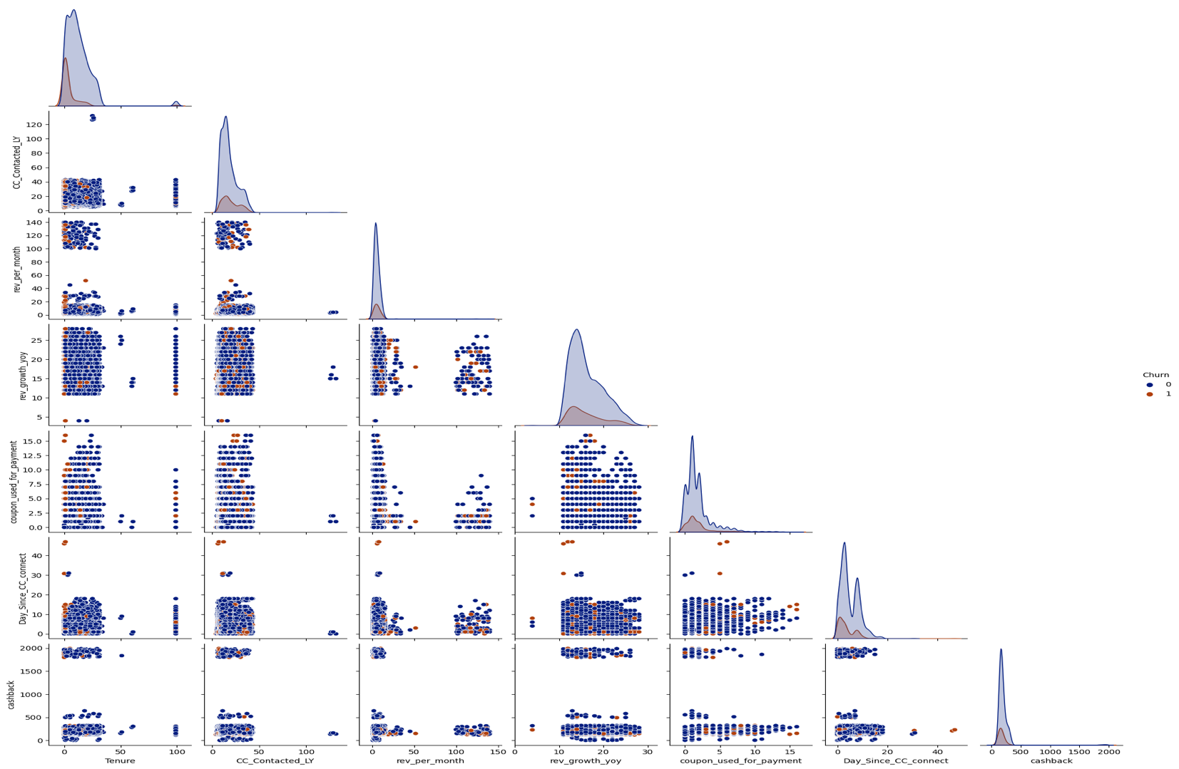

fig 1.38 Pairplot

* **Tenure, the time since the last contact with customer care (Day_Since_CC_connect), and cashback** appear to have the **most significant impact on churn**. **Customers with longer tenure**, **recent contact with customer care, and higher cashback are less likely to churn.**
* Other variables, such as CC**_Contacted_LY, Account_user_count, and usage of coupons for payment**, have **weaker correlations with churn** and may have a less pronounced impact.
* **Monthly revenue and year-over-year revenue growth** **do not have strong correlations** with churn, indicating that these factors may not be the primary drivers of customer churn.

**3. DATA CLEANING AND PRE-PROCESSING**

#### ****a) Missing Value treatment****

#### **The total number of missing values are **4361**, which is **2.04%** of total data.**

#### 

Table 1.5 Missing values in dataset

#### ****Missing Value treatment Approach****

#### **We imputed all missing in categorical using Mode**

#### **For all Numeric, we will use KNN imputer**

Missing Values in the dataset after treatment : 0

**b) Outlier treatment**

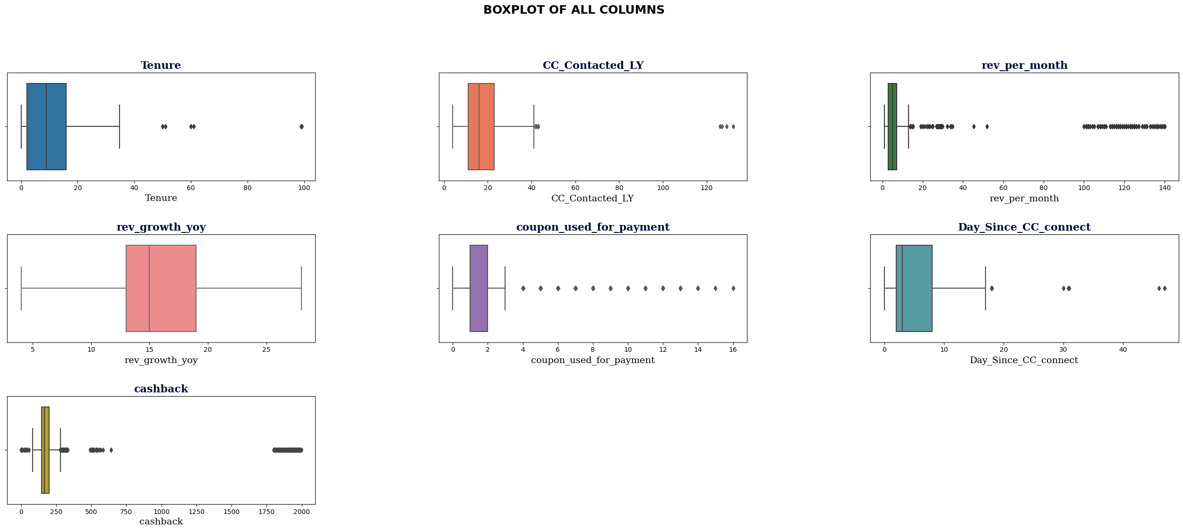fig 1.39 Outliers in the data

**We can see that there are outliers present in the dataset. We have taken the values beyond 1st & 99th % tile as the outliers. Below are the outliers in each variable**

#### **CC_Contacted_LY - **80****

#### **rev_per_month -**113****

#### **rev_growth_yoy -**52****

#### **coupon_used_for_payment- **98****

#### **Day_Since_CC_connect-**94****

#### **Cashback-**226****

**Treatment Approach: We capped the outliers to 1st & 99th %tile.**

**Since our data was already scaled & treated, we did the outlier treatment on scaled data. The result of Outlier treatment on Original as well as on Scaled data is same, hence we considered scaled data for ease of further analysis in model building**

**c) Variable transformation**

**Datatypes correction:**

**Categorical columns: rev_per_month", rev_growth_yoy", "coupon_used_for_payment ", "Day_Since_CC_connect ", "Cashback" were transformed to their correct datatypes after fixing of bad data earlier.**

#### ****Numeric columns:** AccountID , Churn, City_Tier, Complain_ly , CC_Agent_Score. Were converted to object since these were Ordinal/Categorical Variables. We dropped AccountID.**

#### ****Encoding the categorical variables****

#### **The categorical variables need to be encoded before feeding into the KNN imputer, Clustering algorithms & machine learning models. We used **Label encoder** to encode all the categorical columns here.**

**

Table 1.6 **Encoded categorical variables**

#### ****Feature Scaling:****

#### **We scaled the numerical variables in the dataset using **Standard Scaler**. The dataset after scaling is:**

#### 

#### 

Table 1.7 **Scaled variables**

**e) Removal of unwanted variables**

**For further analysis, we will drop the column AccountID as this is only for unique account identification assigned by system and have no significance in analysis.**

#### ****f) Addition of new variables****

#### **- **Clusters**: Variable will be formed after the end of clustering process. However, we did not use the cluster variable in Modeling**

#### **- No other new variable was added in the dataset**

#### ****Clustering & insights from it****

#### We used k-means clustering which is an unsupervised clustering technique for segmenting the

#### Similar type of matches in k numbers of clusters.

We checked 2 methods to find the optimum clusters **&** gone ahead with k=2 for easier interpretation

#### ****Insights from Clusters****

* **Tenure Variation:** The average tenure of customers in both clusters is quite close, with **Cluster 0** having slightly higher tenure compared to **Cluster 1.**
* **Contact Frequency:** **Cluster 1** has a slightly higher average contact frequency in the last year compared to **Cluster 0**, suggesting that **Cluster 1** customers may have more interactions with the company.
* **Service Satisfaction:** **Cluster 1** has a slightly higher average service score, indicating higher levels of satisfaction with the service offered by the company.
* **Account User Count:** Customers in **Cluster 0** have a slightly higher average account user count compared to **Cluster 1.**
* **CC Agent Score:** **Cluster 1** stands out with a significantly higher average agent score compared to **Cluster 0**, indicating more positive interactions with customer care agents.
* **Revenue per Month:** **Cluster 1** exhibits a slightly higher average monthly revenue per customer compared to **Cluster 0**, indicating that Cluster 1 customers may be more profitable.
* **Interaction Frequency:** **Cluster 1** has a significantly higher average interaction frequency compared to **Cluster 0**, suggesting that these customers are more engaged and active.

**Cluster 1** may represent the **company's most loyal and engaged customers**, while **Cluster 0** could be **targeted for improvements in services and addressing complaints**.

**\*Refer Appendix for details on cluster approach, each cluster & Summary.**

#### ****EDA Summary:****

1. **Churn Analysis:**

* **The class imbalance**, with only **16.8% churned** customers, indicates the **need to focus on retaining existing customers** to maintain business stability.

1. **Demographics and Churn:**

* **Customers from City_Tier 3 have a higher churn rate, suggesting that tailored offerings or incentives may be needed to retain these customers.**
* **Churn rates differ based on payment methods and gender. Efforts should be made to engage male customers more effectively.**

1. **Service and Customer Care:**

* **The "Service_Score" analysis shows that higher scores don't necessarily lead to lower churn. Service quality may need improvement.**
* **Customers who complained in the last year had a significantly higher churn rate, indicating a need to address their issues promptly.**

1. **Engagement and Loyalty:**

* **Increasing the number of account users leads to a higher churn rate. Strategies for retaining multi-user accounts should be explored.**
* **Encouraging customers to use mobile devices for logins may reduce churn, as mobile users exhibit a lower attrition rate.**

**EDA Recommendations:**

* **Balancing Churn Rate: Implement strategies to retain existing customers, including offering personalized deals and promotions.**
* **Customized Service Quality: Enhance services for specific segments, like "Regular Plus" customers, who have a higher churn rate. Address service quality issues identified in the data.**
* **Prompt Complaint Resolution: Improve customer care and promptly address customer complaints to prevent churn.**
* **Multi-User Account Strategies: Create incentives or tailored offerings for multi-user accounts to reduce attrition.**
* **Mobile Login Promotion: Promote mobile login to lower churn by making it more convenient for customers.**

#### ****4. Model Building****

#### ****APPROACH****

#### ****Step 1: Segregate dependent variable “Churn” from the independent variables.****

#### ***We assigned all predictors to X & response on y variable before split.***

#### ****Step 2: Split the data into train & Test set****

#### **We split the data with 20% of the records going to the test set & 80% to train, random state of 42 was selected**.** Dataset shape post-split for predictors.**

#### ***Shape of Train dataset: (9008, 17)***

#### ***Shape of Train dataset: (2252, 17)***

#### ****Step 3: Model(s) Building****

#### ****Model Selection****

**In total 14 models were built and their performance was evaluated to find the best fitting model. We built the following models on the dataset & evaluate the performance:**

1. **Decision Tree**
2. **Random Forest**
3. **Linear Discriminant Analysis (LDA)**
4. **k-Nearest Neighbours(KNN)**
5. **Naive Bayes**
6. **Neural Network (ANN)**
7. **SVM**

**Of these models, the models listed below were ensembled and hyperparameter tuned as well to obtain the optimum model.**

1. **Decision Tree**
2. **Linear Discriminant Analysis (LDA)**
3. **Random Forest**
4. **Bagging (base- Decision Tree)**
5. **Adaboost (base- Decision Tree)**
6. **Extreme Gradient Boost (XGB)**
7. **Categorical Boost(CatBoost)**
8. **Neural Network (ANN)**
9. **SVM**

#### ****Step 4: Model validation (Selection of appropriate Evaluation Matrix)****

**In a churn prediction scenarios wherein the dataset is also imbalanced with 16.8% Churn cases, the primary goal is to identify potential churners (Churn cases). Missing even a small fraction of true churners can be costly for the business, as retaining these customers is often more cost-effective than acquiring new ones. Therefore, prioritizing recall, or other metrics that consider true positive rates, is a suitable approach for imbalanced churn prediction dataset**

**This ensures that the model is effective in capturing Churn cases, which aligns with the business objective of reducing customer attrition. However, it's also essential to consider other metrics like precision, F1 score, and AUC-ROC in combination with recall to get a comprehensive evaluation of the model's performance.**

#### ****Step 4: Model Tuning ( Effort to improve model performance)****

**A combination of ensemble methods and hyperparameter tuning can lead to highly accurate and robust machine learning models.**

**Ensemble Methods:**

**Ensemble methods involve combining multiple machine learning models to improve overall predictive performance. The key idea is to leverage the strengths of different models and overcome their individual weaknesses**

**Hyperparameter Tuning:**

**Grid Search, also known as parameter sweeping, is one of the most basic and traditional methods of hyperparametric optimization.**

**Hyperparameters are parameters that are not learned from the data but need to be set before training a machine learning model. Hyperparameter tuning is the process of finding the best combination of hyperparameters to optimize a model's performance.**

**Data Imbalance**

**While the dataset is imbalanced we have not oversampled the minority class to avoid synthetic data, since the models were able to perform fairly good without need to introducing oversampled data. However, this is also one way to tune the model for better results when data is imbalanced.**

#### ****Step 5: Model(s) Comparison & Optimum Model.****

**Model Comparison**

**Train Data**

|  |  |  |  |  |  |  |  |
| --- | --- | --- | --- | --- | --- | --- | --- |
| **Model** | **Majority Class(Not Churn)** | | | **Minority Class( Churn)** | | | **accuracy** |
| **Precision** | **Recall** | **f1-score** | **Precision** | **Recall** | **f1-score** |
| Decision Tree | 100% | 100% | 100% | 100% | 100% | 100% | 100% |
| Random Forest | 100% | 100% | 100% | 100% | 100% | 100% | 100% |
| Adaboost | 100% | 100% | 100% | 100% | 100% | 100% | 100% |
| XGBoost with Tuning | 100% | 100% | 100% | 100% | 100% | 100% | 100% |
| Catboost | 100% | 100% | 100% | 100% | 100% | 100% | 100% |
| Support Vector | 99.96% | 98.92% | 99.44% | 94.87% | 99.80% | 97.27% | 99.07% |
| KNN | 99.50% | 99.73% | 99.61% | 98.65% | 97.47% | 98.05% | 99.36% |
| Bagging Classifier | 99.26% | 99.92% | 99.59% | 99.59% | 96.27% | 97.90% | 99.31% |
| Regularized Decision Tree | 98.85% | 99.52% | 99.18% | 97.52% | 94.20% | 95.83% | 98.63% |
| Random Forest with Tuning | 97.45% | 90.21% | 93.69% | 64.29% | 88.20% | 74.37% | 89.88% |
| Neural Network | 96.73% | 99.80% | 98.24% | 98.81% | 83.13% | 90.30% | 97.02% |
| Linear Discriminant Analysis | 87.56% | 97.82% | 92.41% | 73.59% | 30.47% | 43.09% | 86.60% |
| Tuned LDA | 87.56% | 97.82% | 92.41% | 73.59% | 30.47% | 43.09% | 86.60% |
| Naive Bayes | 85.80% | 97.54% | 91.29% | 60.89% | 19.20% | 29.19% | 84.49% |

Table 1.8 Model comparison Test

**Test Data**

Best Model

|  |  |  |  |  |  |  |  |  |
| --- | --- | --- | --- | --- | --- | --- | --- | --- |
| **Model** | **Majority Class(Not Churn)** | | | **Minority Class( Churn)** | | | **accuracy** | **Overfit** |
| **Precision** | **Recall** | **f1-score** | **Precision** | **Recall** | **f1-score** |
| SVM with Tuning | 98.97% | 97.90% | 98.43% | 90.63% | 95.20% | 92.86% | 97.42% | **No** |
| CatBoost with Tuning | 98.67% | 99.62% | 99.14% | 98.15% | 93.69% | 95.87% | 98.58% | **No** |
| Random Forest | 97.61% | 99.14% | 98.37% | 95.64% | 88.64% | 92.01% | 97.29% | **Slightly Overfit** |
| KNN | 97.62% | 99.25% | 98.42% | 96.16% | 88.64% | 92.25% | 97.38% | **Slightly Overfit** |
| XGBoost with Tuning | 97.36% | 99.19% | 98.27% | 95.84% | 87.37% | 91.41% | 97.11% | **Slightly Overfit** |
| Adaboost | 97.21% | 99.62% | 98.40% | 98.00% | 86.62% | 91.96% | 97.34% | **Slightly Overfit** |
| Tuned Random Forest | 96.41% | 89.60% | 92.88% | 63.38% | 84.34% | 72.37% | 88.68% | **Slightly Overfit** |
| Decision Tree | 96.50% | 96.55% | 96.53% | 83.80% | 83.59% | 83.69% | 94.27% | **Yes** |
| Bagging Classifier | 96.47% | 98.71% | 97.58% | 93.20% | 83.08% | 87.85% | 95.96% | **Yes** |
| Regularized Decision Tree | 95.44% | 96.93% | 96.18% | 84.47% | 78.28% | 81.26% | 93.65% | **Yes** |
| Neural Network | 94.63% | 98.76% | 96.65% | 92.70% | 73.74% | 82.14% | 94.36% | **Yes** |
| LDA | 87.22% | 97.84% | 92.23% | 76.47% | 32.83% | 45.94% | 86.41% | **Yes** |
| Tuned LDA | 87.22% | 97.84% | 92.23% | 76.47% | 32.83% | 45.94% | 86.41% | **Yes** |
| Naive bayes | 85.26% | 97.84% | 91.12% | 67.21% | 20.71% | 31.66% | 84.28% | **Yes** |

Table 1.9 Model comparison Test

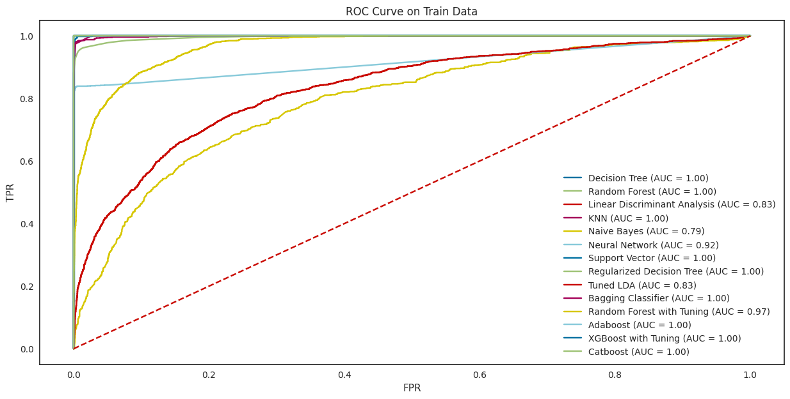Fig 1.40 ROC-AUC Curve Train data

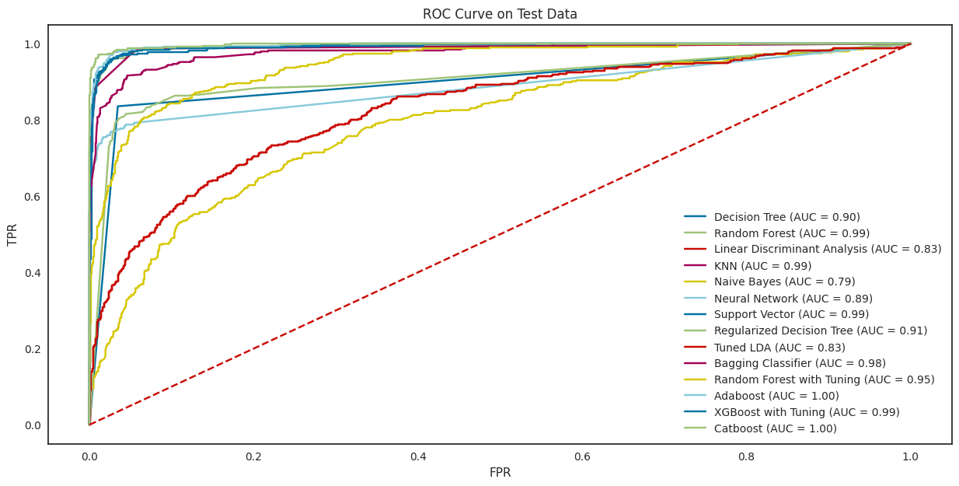

Fig 1.41 ROC-AUC Curve Test data

* Model explanation, Confusion matrix & inferences are in Appendix for each of 14 models built.

**Model Comparison**

* "**SVM," "CatBoost,"** exhibit **excellent performance** with high recall for Churn (minority class). They successfully identify customers at risk of churning, minimizing false negatives.
* **SVM** has the **highest recall** of the **minority class (95.20%),** followed by **Catboost (93.69%)** and **Random Forest (88.63%).**
* **Linear Discriminant Analysis (32.83%)** and **Naive Bayes (20.71%)** have the **lowest recall** of the minority class. These also exhibit high overfitting.
* In general, the **decision Tree**, **tuned models** (**Random Forest with Tuning and Tuned** **LDA**) **have lower recall** on the **minority class than the untuned models**. This is likely because the **tuned models are less overfit than the untuned models**. Further, these are more focused on maximizing overall accuracy, which can lead to sacrificing recall on the minority class
* The accuracy and other measuring parameter of a model can be further improved by trying various other combinations of hyperparameter. It is an iterative process.

**Best Model**

**SVM Model with Tuning**

SVM offers very high accuracy compared to other classifiers such as logistic regression, and decision trees. SVM constructs a hyperplane in multidimensional space to separate different classes. It generates optimal hyperplane in an iterative manner, which is used to minimize an error. The core idea of SVM is to find a maximum marginal hyperplane(MMH) that best divides the dataset into classes

We build a Support Vector classifier & search for the best fit model, using Grid Search Cross

Validation Technique with the following values:

*Regularisation Parameter (C): 0.1, 1, 10*

*Gamma: 0.01, 0.1, 1*

*Kernel: rbf, poly*

*Class Weight: balanced*

We obtain the best fit model with the parameters:

*'C': 10,*

*'class_weight':'balanced',*

*'gamma': 0.1,*

*'kernel': 'rbf'*

The best fit model parameters are then used for creating a SVM classifier model & predicting

the train & test labels based on the independent variable values. The performance of the model on

the train & test set are as follows: -

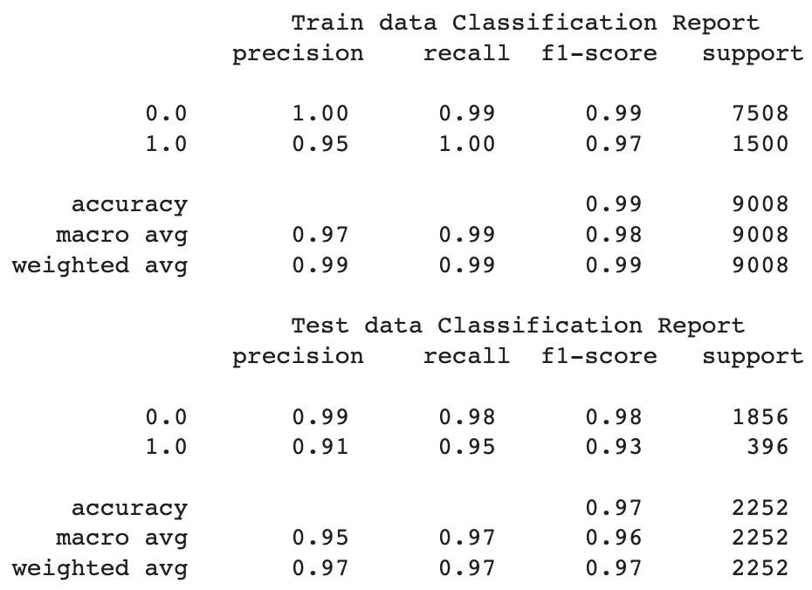

Table 1.10 Classification report SVM

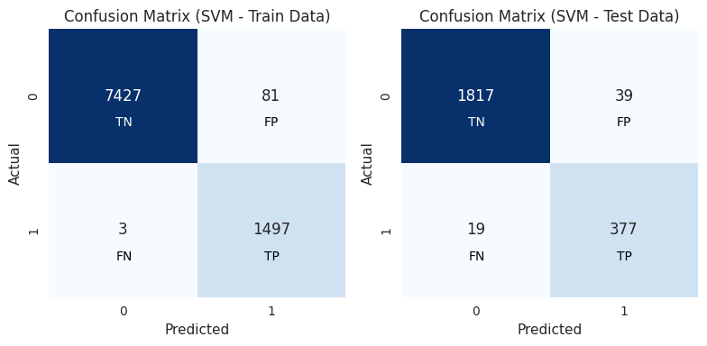

Fig 1.42 Confusion Matrix SVM

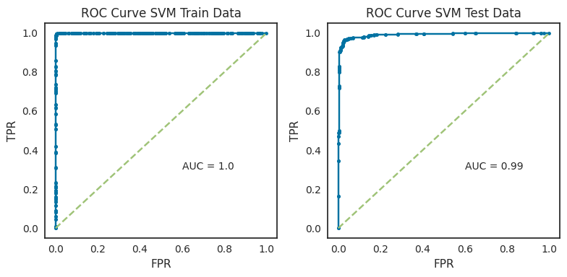

Fig 1.43 ROC-AUC Curve SVM

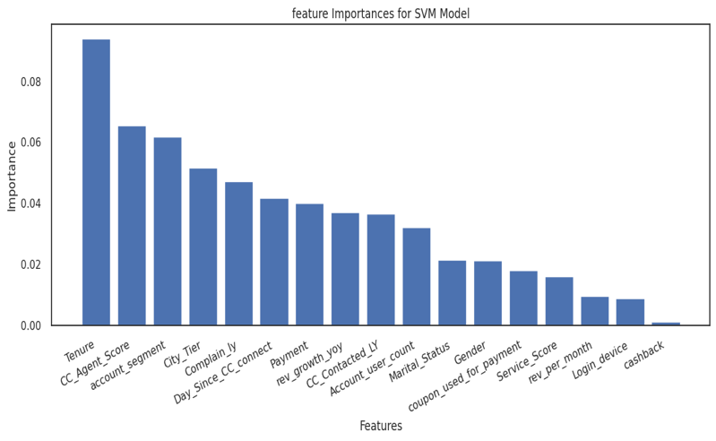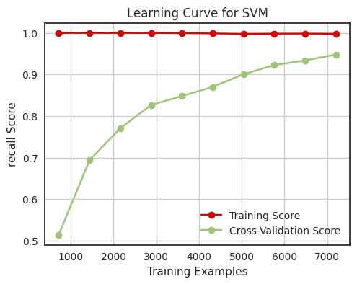

Fig 1.44 Feature Importance & Learning Curve SVM

**Best Model Insights**

* The model is **able to identify a very high proportion of the actual positive cases** (**95% recall for the minority class)**. This is important for applications where it is critical to avoid false negatives.
* The model is **not overfitting the training data.** This is evident from the fact that the cross-validation scores are very close to the training accuracy (**mean cross-validation score is 94.8%,** which is very close to the **training accuracy of 99%**)
* The **model is able to generalize well to new data**. This is evident from the fact that the training score and the cross-validation score are both high and very close.
* Overall, **the SVM model is a very good choice for imbalanced classification** here. It is able to achieve a high recall for the minority class without overfitting the training data.

**Most Optimum Model & Business Implication**

* If the business is looking for a model, which can help them to **target potential churning customers and thus helping them to reduce client acquisition cost than model with** **higher precision makes sense**. As in this correctness of predicting churners is more important. Lower the percentage means that the company lost money on the respective lead.
* If the business is looking to know **high number of churners irrespective of cost of acquisition than recall makes more sense**. Here they want to maximise prediction of employee opting for package.
* In the second case, the business should use the **SVM** model. It has the **highest recall (95.20%),** meaning that it is **very good at identifying churn customers**. This is important because it allows the business to target their churn prevention efforts to the customers who are most likely to churn.
* For a **balanced model** which provided a good trade-off between precision & recall, we can consider **Catboost model** with recall as **93.69% & having an excellent f1-score of 95.87% for minority class.** The model also has best **precision of 98.15%** among the models.
* It's important to note that both **SVM** and **CatBoost** might result in some false positives (high precision) which could lead to additional retention costs. The business need to weigh the cost of false positives against the benefits of identifying potential churners.

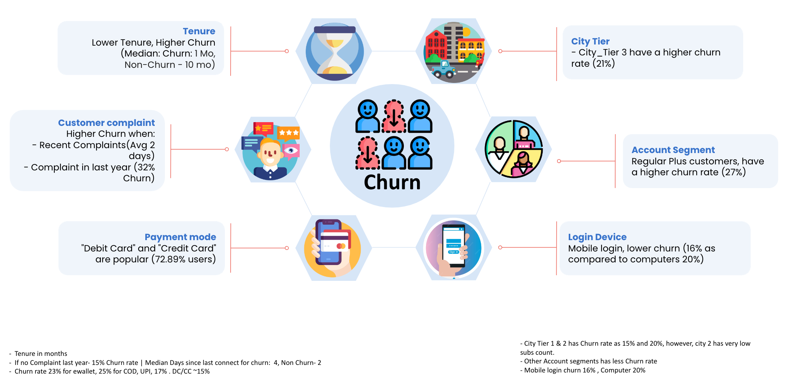**FINAL INSIGHTS FOR THE BUSINESS**

Based on the analysis, we derived some insights that can help us understand the customer churn problem better.

* **Tenure** appears to be **most important** in **Churn** which is obvious that if a customer is with a business for longer time, would less likely to churn. The lower tenure customer may have less attachment or commitment with the service
* **Customers from City_Tier 3** have a **higher churn rate of 21%** as compared to other tiers, suggesting that they may need more tailored offerings or incentives to retain them.
* **Customers** who have **account segment, as Regular Plus**, have a **higher churn rate of 27%,** indicating that they may have higher expectations or lower satisfaction with the service.
* **Customers who complained in the last year have high churn rate (32% churn)** or **they connect more recently than non-chruners**, implying that they may have unresolved issues, facing frequent problems or dissatisfaction with the customer care.
* **Customers** who **use debit card or credit card**, or **use mobile devices for login** have a **lower churn** **rate**, implying that they may have more engagement or satisfaction with the service.

**RECOMMENDATIONS**

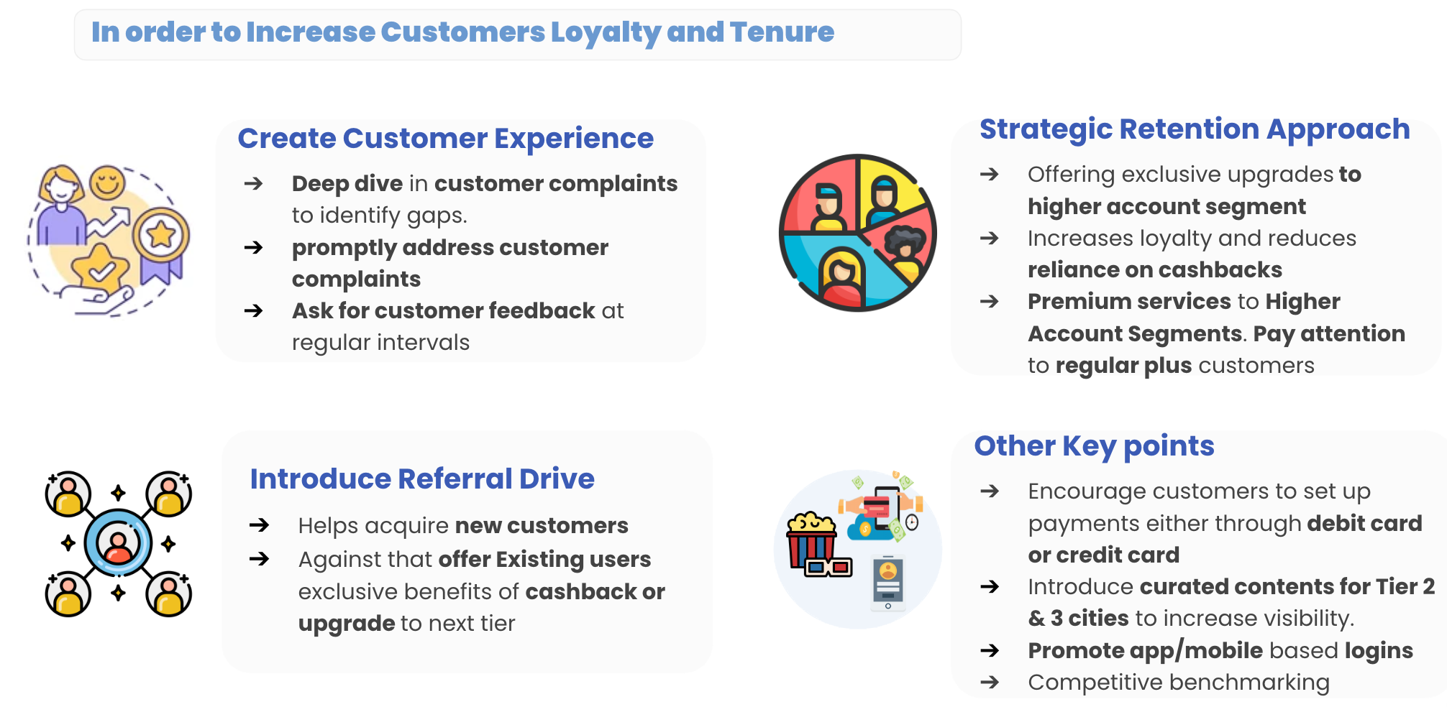

To reduce the churn or retain a customer, it is very important that we increase the customer loyalty and tenure, the following points can help in achieving so:

* First & foremost, the DTH provider need to **immediately look at their customer service**, a **deep dive in customer complaints to identify the gaps**. Since, we do not have more data for customer complaints, **we recommend the customer service team to review it basis category of complaints, wait time, first response and resolution time of complaint**.

Not only addressing above, they need to **find out the root cause of the complaints** **& try to avoid them arising at first place**. May look for alternate such self-serve on app or website.

* Second, we found that the business is spending a lot on cashback & coupons, while this is good way to attract customers, we recommend that the business should look for alternate, such as **an account upgrade to higher tier basis loyalty points**. They need to **pay attention to the regular plus customers** who have a **good revenue but high churn rate**.
* Another strategy the business can apply is to **introduce referral drive**, this will not only **help acquire new customers**, the **existing users can get exclusive coupons/cashback to upgrade their accounts** to higher tiers.
* Few other key points the business can look at are, **encourage users to make payment via Debit/credit card**, **Introduce curated contents specific to city tiers** instead of common for all. And **Promote app/mobile logins** & **contents which users can access on the go**.
* Last but not the least, doing a **competitive benchmarking** to identify what the competitors has to offer customers that is leading a churn can help the business know where they stand and review their strategies.

**APPENDIX**

#### ****Data Description****

|  |  |
| --- | --- |
| Variable | Description |
| AccountID | Account unique identifier |
| Churn | Account churn flag (Target) |
| Tenure | Tenure of account |
| City_Tier | Tier of primary customer's city |
| CC_Contacted_L12m | How many times all the customers of the account has contacted customer care in the last 12 months |
| Payment | Preferred Payment mode of the customers in the account |
| Gender | Gender of the primary customer of the account |
| Service_Score | Satisfaction score given by customers of the account on service provided by the company |
| Account_user_count | Number of customers tagged with this account |
| account_segment | Account segmentation on the basis of spend |
| CC_Agent_Score | Satisfaction score given by customers of the account on customer care service provided by the company |
| Marital_Status | Marital status of the primary customer of the account |
| rev_per_month | Monthly average revenue generated by account in last 12 months |
| Complain_l12m | Any complaints have been raised by account in last 12 months |
| rev_growth_yoy | Revenue growth percentage of the account (last 12 months vs last 24 to 13 months) |
| coupon_used_l12m | How many times customers have used coupons to do the payment in the last 12 months |
| Day_Since_CC_connect | Number of days since no customers in the account has contacted the customer care |
| cashback_l12m | Monthly average cashback generated by account in the last 12 months |
| Login_device | Preferred login device of the customers in the account |

**Information About data post cleaning**

### **Post the data cleaning & datatype transformation, here is the updated data types:**

### 

**Table : Information about data post cleaning**

#### ****Correlation Insights- Detailed****

1. **Positive Relationships:**
   * Customers with longer tenure tend to generate higher monthly revenue and have been using their credit cards for a longer period.
   * There is a strong positive relationship between monthly revenue and cashback, indicating that customers who generate more revenue receive higher cashback.
   * In higher city tiers, customers are more likely to use E-wallets for payments.
2. **Negative Relationships:**
   * Longer-tenured customers are less likely to belong to the "Regular Plus" account segment and are slightly less likely to be married.
   * Customers in higher city tiers are less likely to be in the "Regular Plus" account segment.
   * Customers receiving higher cashback are less likely to be in the "Regular Plus" account segment.
3. **Low Relationships:**
   * Gender does not strongly correlate with most variables, suggesting that it may not significantly impact other customer behaviors.
   * Contacting customer care in the last year does not show strong correlations with other variables, indicating that this activity might not strongly influence other aspects of customer behaviour.

#### ****Data Imbalanced?****

From the below target variable plot, we can clearly see the **class Imbalance here. only 16.8% of** the customers are churned.

Churn rates vary significantly across different categorical variables, with some categories having higher churn rates than others. For instance, certain city tiers, payment methods, gender, account segments, and marital status categories have notably higher churn rates compared to their counterparts.



#### **Fig:Target Variable**

To address this issue in the context of the DTH service provider, the following actions can be taken:

**Collect More Data**: Collecting more data, especially from the minority class, can help improve the balance in the dataset. Engaging with more customers who have churned to gather their feedback and understanding their pain points can be valuable.

**Resampling**: If more data is unavailable, to balance the dataset, we can employ resampling techniques such as SMOTE. This can involve oversampling the minority class (Churn) by generating synthetic samples or under sampling the majority class (Not Churn). Both methods can help balance the class distribution and improve model performance.

#### ****Clustering****

#### We used k-means clustering which is an unsupervised clustering technique for segmenting the

#### Similar type of matches in k numbers of clusters.

We checked 2 methods to find the optimum clusters **&** gone ahead with k=2 for easier interpretation

#### Method 1: First, we scaled the data & applied PCA with 3 components wherein we got the k clusters as 4 using elbow visualizer plot. However, since we only took 3 principle components from PCA that didn’t capture much variance hence we considered it as not sufficient to proceed further & did not go ahead with it.

#### Method 2: In this, we took the scaled data plotted the distortion score Elbow and got k=5.

#### 

#### **Let’s confirm value of k among these using silhouette score. We'll check on 2 to 8**

#### 

**silhouette score**

- **Silhouette Score close to 1** => Clusters are well separated from each other.

- **Minimum Sil-Width = +ve** => No Data points are mapped incorrectly to their cluster

In this case, the other clusters don't well differentiate because 2 groups out of a set of data points are obvious.

**For k = 2,** we have the highest **Silhouette Score (0.134)** among the options. The **Minimum Silhouette** Width is also **positive (0.012),** indicating that there is a reasonable separation between the clusters.

Taking 6 Clusters basis previous elbow method shows that increasing k post 6 found the point where adding more clusters provides diminishing returns in terms of reducing the inertia. However, having 6 cluster might become difficult in interpretability and practical implications of the resulting clusters.

We have gone ahead with k=2 for easier interpretation

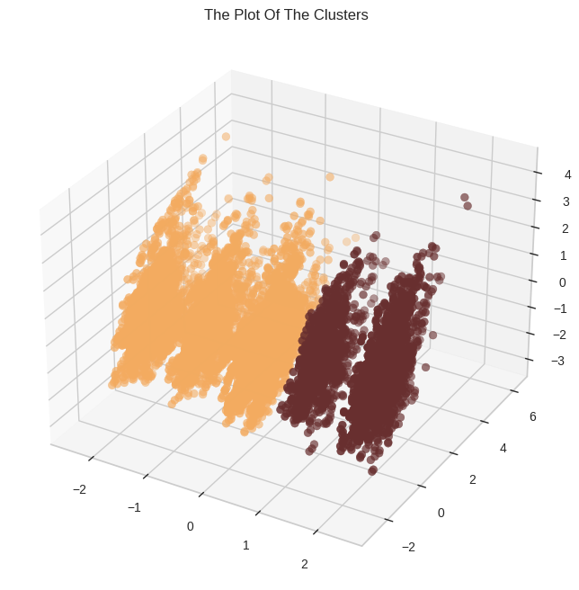

Plot of the clusters

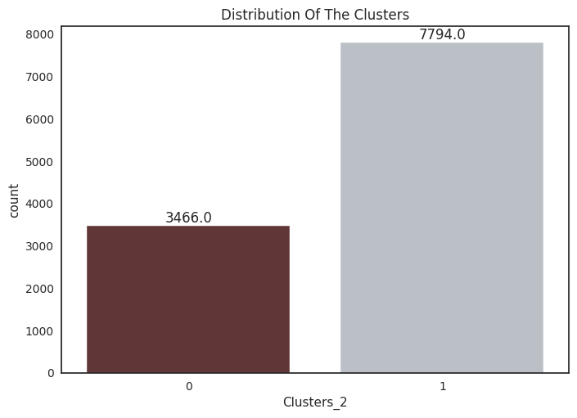

**Cluster Profiles**

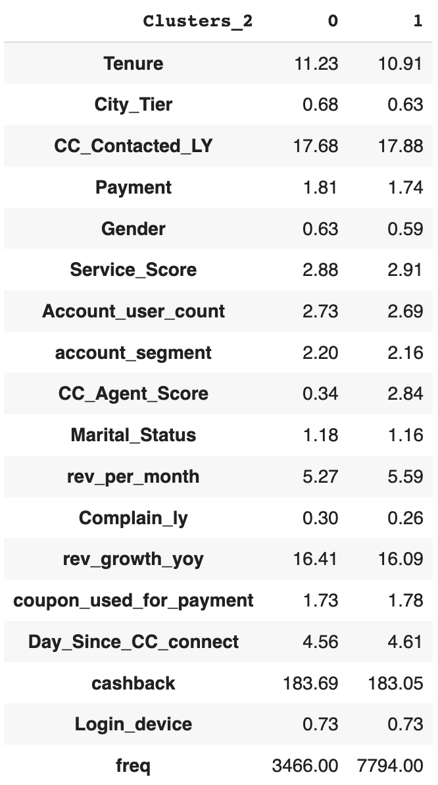

**Cluster Profiles**

**Cluster 0:**

* Customers in Cluster 0 have a slightly longer tenure of approximately 11.23 months, indicating loyal relationships.
* They exhibit moderate service satisfaction with a service score of 2.88 but generate significant monthly revenue of approximately 5.27 units.
* Cluster 0 has lower customer care agent scores (0.34) and a higher percentage of married customers (approximately 1.18), which suggests an area for improvement.
* These customers file relatively fewer complaints, with a complaint rate of about 0.30, indicating overall satisfaction.

**Cluster 1:**

* Customers in Cluster 1 have a slightly shorter tenure of approximately 10.91 months but higher customer care agent scores (2.84).
* They generate slightly higher monthly revenue (approximately 5.59 units) and have a lower number of complaints (around 0.26).
* The majority of customers in this cluster are male (approximately 0.63) and unmarried (around 1.16).
* Cluster 1 represents a larger customer base with significantly more frequent interactions (7794 times).

Missing Value Visualization:

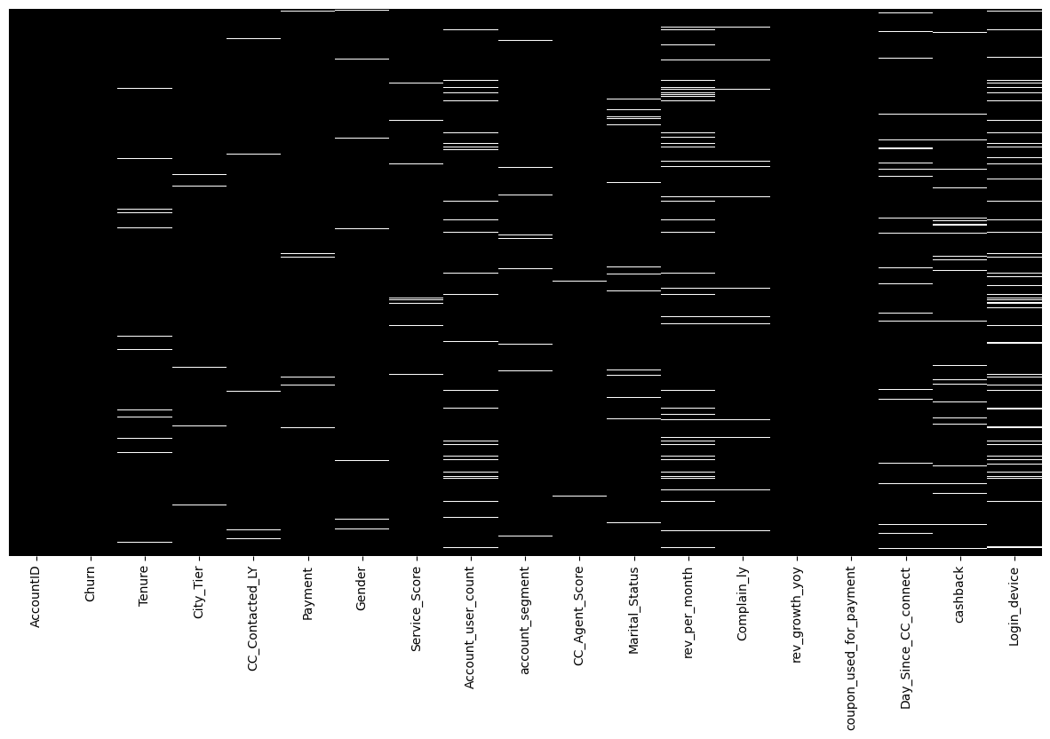

**Missing value visualization**

#### ****c) EDA Summary & Insights****

1. **Exploratory Data Analysis Summary:**

* The dataset consists of **11,260 rows** and **19 columns** with a **binary target variable, "Churn,"** representing **customer attrition**.
* Target Variable has **class imbalance** with **only 16.8%** of customers **marked as churned**.
* **Numerical features** exhibit **varying distributions**, such as **positively skewed tenure**, **moderate-skewed revenue**, and **highly skewed cashback**.
* **Categorical variables** like "**City_Tier**" show that the **majority of customers are in Tier 1 cities**, and **payment methods** **like "Debit Card" and "Credit Card" are popular**.
* Analysis of categorical variables indicated relationships between features and churn, highlighting the impact of "City_Tier," "Payment," and "Complain_ly" on customer attrition.
* In numerical features, **lower tenure, higher CC contacts in the last** year, **lower monthly** **revenue**, and **higher cashback amounts** were **associated with** **higher churn rates**.

1. **Data Preparation:**
   * Unwanted variable **Account id was removed**
   * **Missing values** were **imputed using Mode for categorical** & **KNN for numerical**, **with 2.04%** of the data containing missing values.
   * **Outliers were treated** by **capping** values at the **1st and 99th percentiles**.
   * **Label Encoding** was done **for categorical** and **Standard scaling** was applied to the **numerical variables** in the dataset.

**EDA Insights:**

1. **Churn Analysis:**

* **The class imbalance**, with only **16.8% churned** customers, indicates the **need to focus on retaining existing customers** to maintain business stability.

1. **Demographics and Churn:**

* **Customers from City_Tier 3 have a higher churn rate, suggesting that tailored offerings or incentives may be needed to retain these customers.**
* **Churn rates differ based on payment methods and gender. Efforts should be made to engage male customers more effectively.**

1. **Service and Customer Care:**

* **The "Service_Score" analysis shows that higher scores don't necessarily lead to lower churn. Service quality may need improvement.**
* **Customers who complained in the last year had a significantly higher churn rate, indicating a need to address their issues promptly.**

1. **Engagement and Loyalty:**

* **Increasing the number of account users leads to a higher churn rate. Strategies for retaining multi-user accounts should be explored.**
* **Encouraging customers to use mobile devices for logins may reduce churn, as mobile users exhibit a lower attrition rate.**

**EDA Recommendations:**

* **Balancing Churn Rate: Implement strategies to retain existing customers, including offering personalized deals and promotions.**
* **Customized Service Quality: Enhance services for specific segments, like "Regular Plus" customers, who have a higher churn rate. Address service quality issues identified in the data.**
* **Prompt Complaint Resolution: Improve customer care and promptly address customer complaints to prevent churn.**
* **Multi-User Account Strategies: Create incentives or tailored offerings for multi-user accounts to reduce attrition.**
* **Mobile Login Promotion: Promote mobile login to lower churn by making it more convenient for customers.**

**Model Building**

In the below section, we will go through all the models build, their description and evaluation matrix one by one

**Decision Tree Model**

**A decision tree, as the term suggests, uses a tree-like model to make predictions.**

* **A decision tree splits data into multiple sets of data. Each of these sets is then further split into subsets to arrive at a decision**
* **It can be used to model highly non-linear data.**
* **Decision trees are non-parametric means no specific data distribution is necessary. Decision trees easily handle continuous and categorical variables.**

**A criterion of Gini is selected**

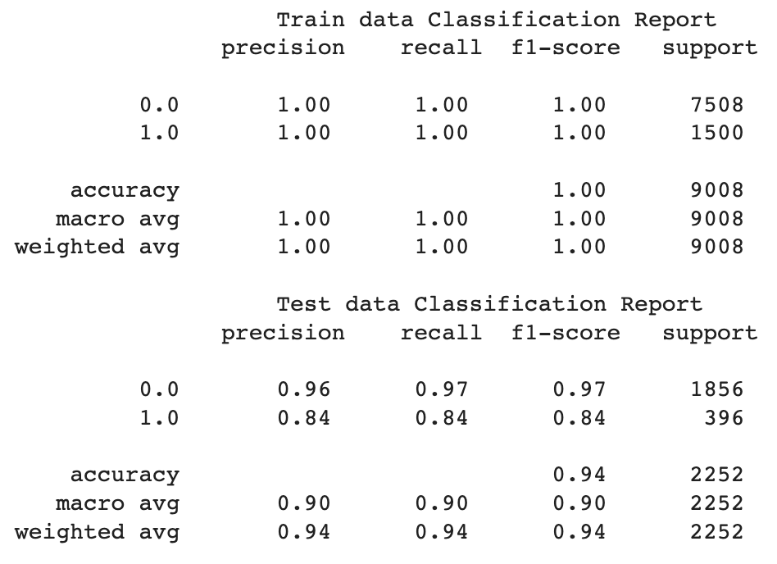

Table Classification report Decision Tree

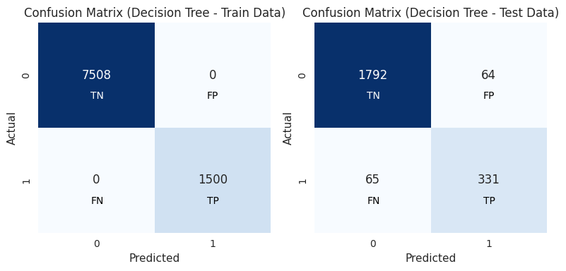

Fig Confusion Matrix Decision Tree

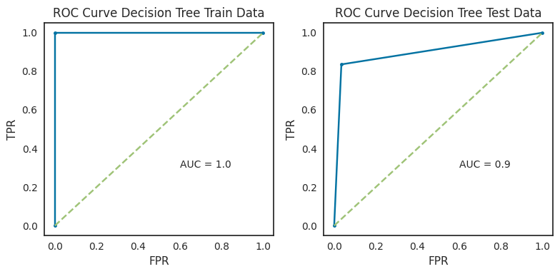

Fig ROC-AUC Curve Decision Tree

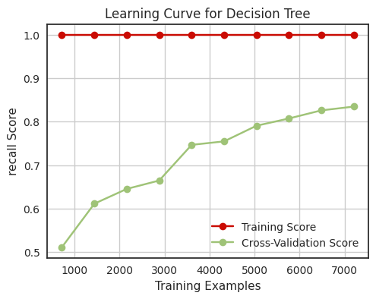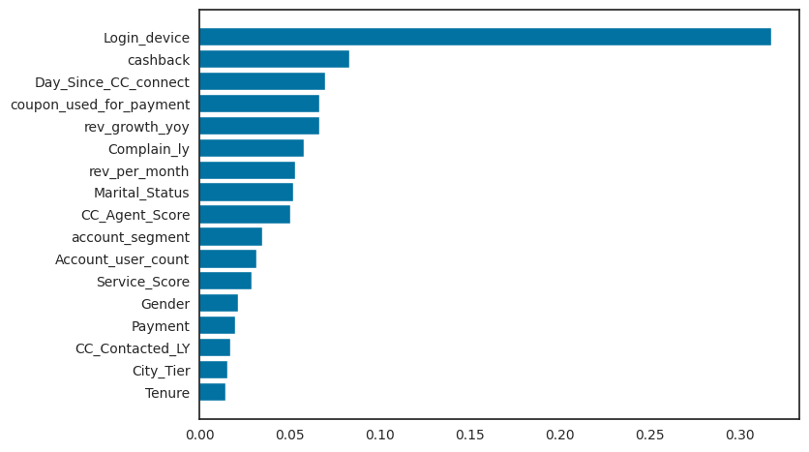

Fig Learning Curve Decision Tree Fig Feature importance Decision Tree

**Insights**

* The model is able to identify a fair proportion of the actual positive cases (**84% recall for the minority class**). This is important for applications where it is critical to avoid false negatives.
* The **model is overfitting the training data**. This is evident from the relatively large difference between the training accuracy and the cross-validation score.
* The **model may not generalize well to new data**. This is evident from the plateau in the learning curve.
* Regularization can help to prevent the model from overfitting the training data. Or Pruning the tree can help to reduce the complexity of the tree and prevent overfitting

**Random Forest Model**

Random Forest is a powerful ensemble learning technique, often regarded as an extension of decision trees. It operates through the following steps:-

* **Random Sampling**: Random Forest selects random subsets of data from the given dataset.
* **Decision Trees**: For each of these data subsets, it constructs a decision tree, making predictions on each subset.
* **Voting**: Random Forest then aggregates the predictions from all decision trees through a voting mechanism.
* **Majority Rule**: The prediction result with the highest number of votes becomes the final prediction.

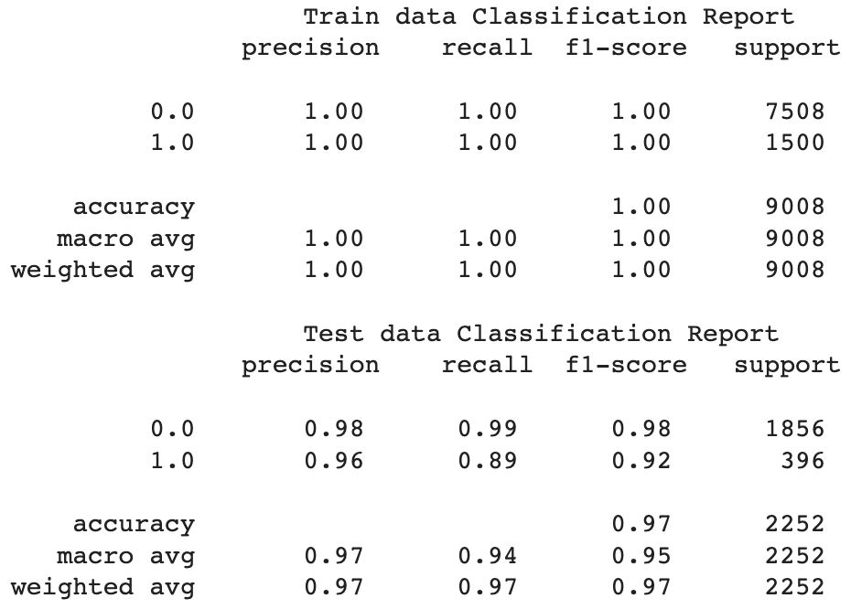

Table Classification report Random Forest

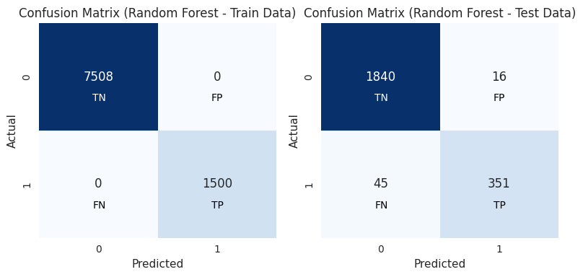

Fig Confusion Matrix Random Forest

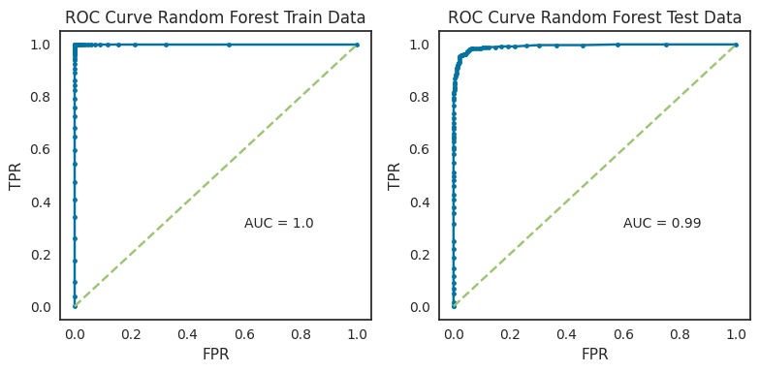

Fig ROC-AUC Curve Random Forest

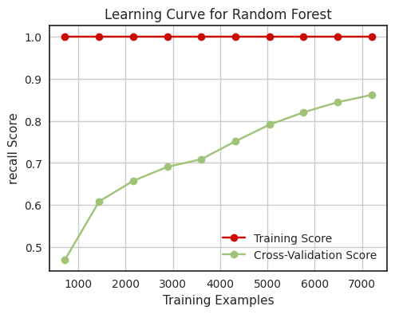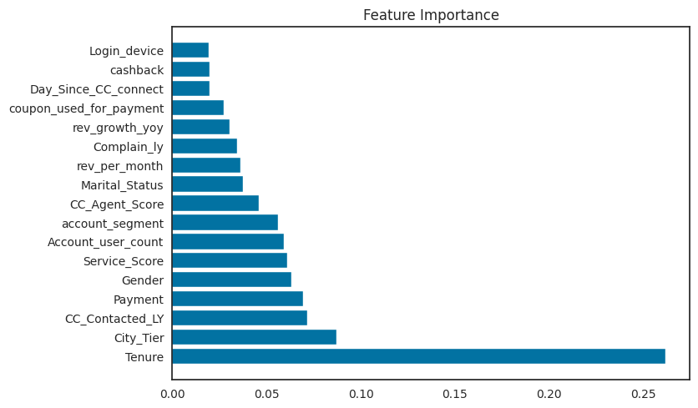

Fig Learning Curve Random Forest Fig Feature importance Random Forest

**Insights**

* The random forest model is performing well on the test set, with a **high recall for the minority class and a low level of overfitting**.
* The model is **able to identify a good proportion of the actual positive cases (89% recall for the minority class**). This is important for applications where it is critical to avoid false negatives.
* The **model is slightly overfitting the training data**. The overfitting is not severe and the model is still able to generalize well to new data.
* However, **we will tune the model to reduce overfitting** & see if it improves recall

**Linear Discriminant Analysis ( LDA)**

**Linear Discriminant Analysis** predicts the class in dependent variable using a linear combination of independent variables.

LDA projects the features in higher-dimensional space onto a lower dimensional space. LDA then searches for a linear combination of independent variables (line, plane, or hyperplane) that best separates the classes of the dependent variable.

**Assumptions of LDA:**

* Each feature in the dataset is a gaussian distribution
* Each feature has the same variance, the value of each feature varies around the mean with the same amount on average.
* Each feature is assumed to be randomly sampled.
* Lack of multicollinearity in independent features. Increase in correlations between independent features and the power of prediction decreases.

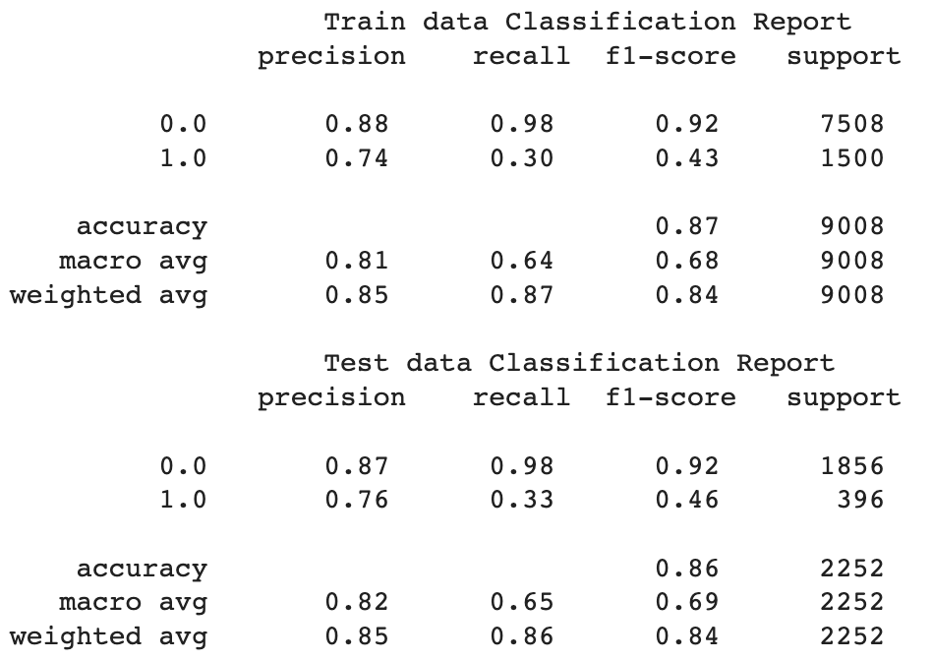

Table Classification report LDA

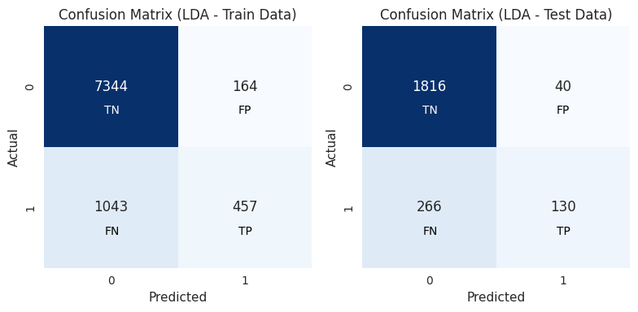

Fig Confusion Matrix LDA

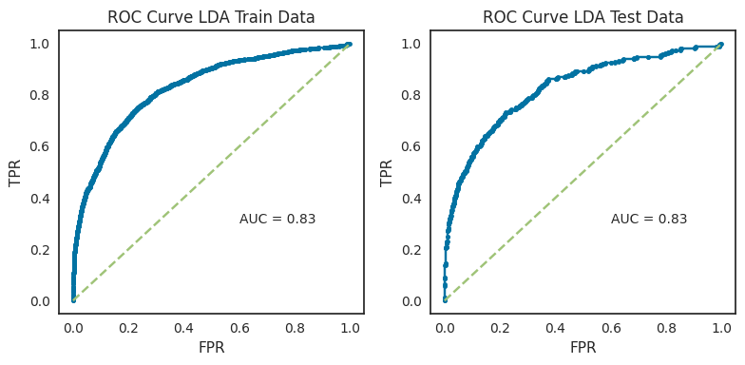

Fig ROC-AUC Curve LDA

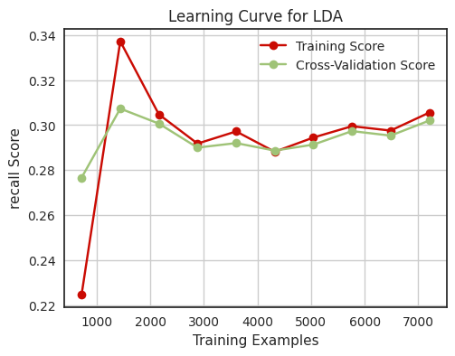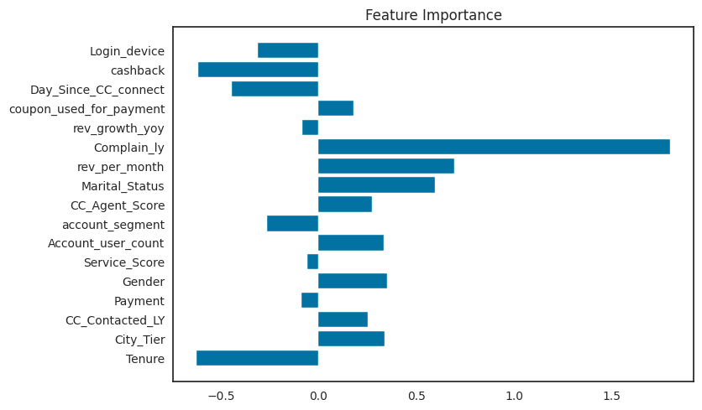

Fig Learning Curve LDA Fig Feature importance LDA

**Insights**:

* The model is **only able to correctly predict 33% of the churn customers**. This is a **very low recall score**, and it is not good enough for churn prediction
* The LDA Model is **overfitting the training data**.
* **Not able to generalize well to unseen data** hence **not a good model** for predicting churn.

**K-Nearest Neighbors (KNN)**

The data-point in KNN is classified on the basis of its **k Nearest Neighbors**, followed by the **majority vote of those nearest neighbors**; a query point is assigned the data class which has the most representatives within the nearest neighbors of the point

K-NN is a non-parametric algorithm, which means it does not make any assumptions on underlying data

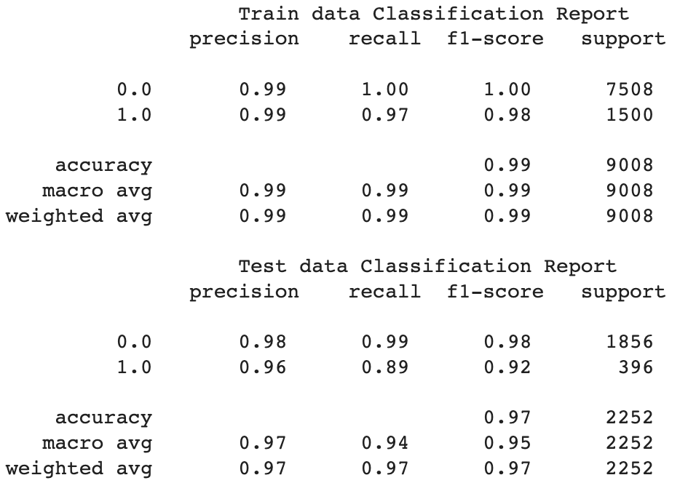

Table Classification report KNN

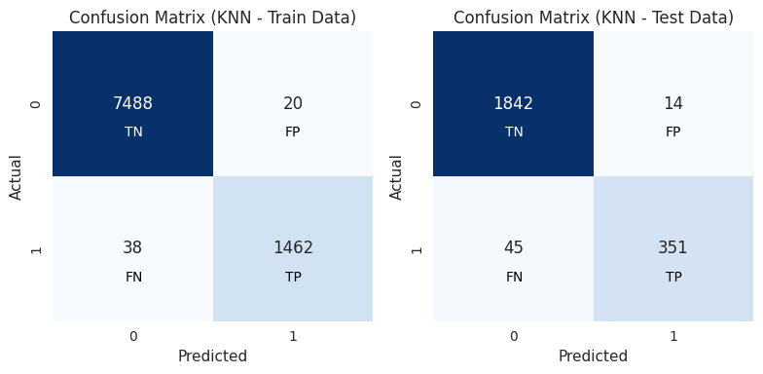

Fig Confusion Matrix KNN

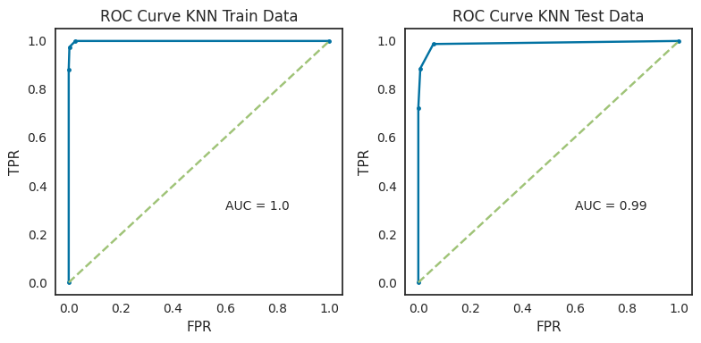

Fig ROC-AUC Curve KNN

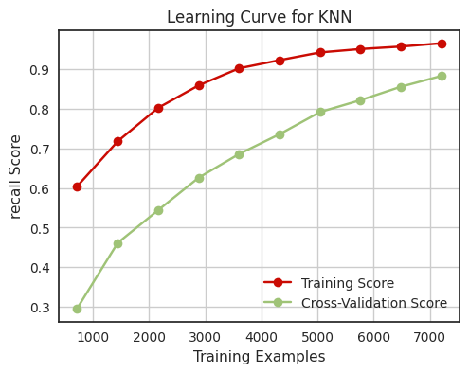

Fig Learning Curve KNN

**Insights**

* The K-Nearest Neighbors (KNN) model exhibits **overall good performance on both the training and test data.**
* It achieves high precision, recall, and F1-score, particularly for non-churn cases (0.0) while drops slightly on test data. The **recall on train set is 0.97** while **0.89 on test set**.
* The learning curve shows that the training accuracy and cross-validation accuracy both converge quickly. The **model slightly overfits**

**Naive Bayes**

Naïve Bayes Classifier can be trained easily and fast and can be used as benchmark model

It requires a strong assumption of independent predictors, so when the model has a bad performance, the reason leading to that may be the dependence between predictors.

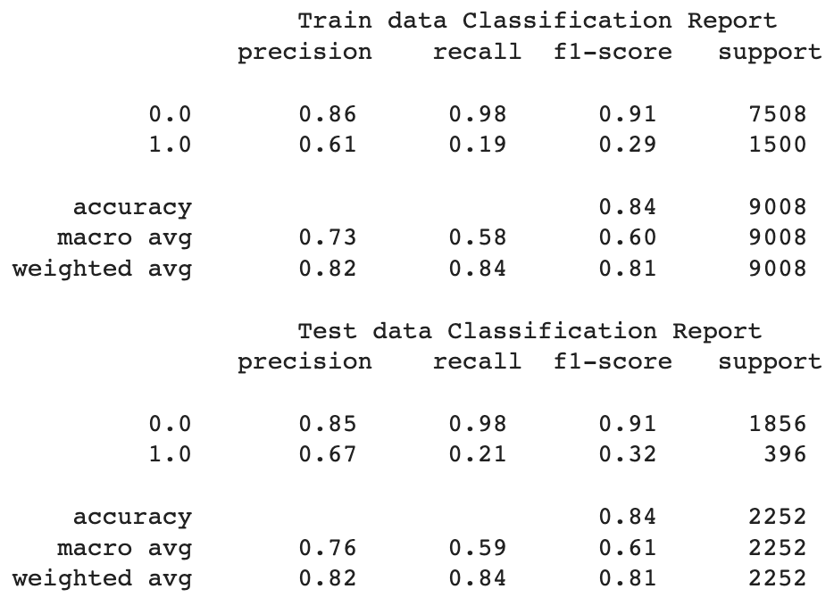

Table Classification report Naïve Bayes

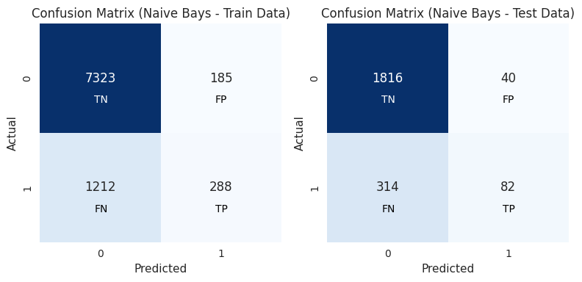

Fig Confusion Matrix Naïve Bayes

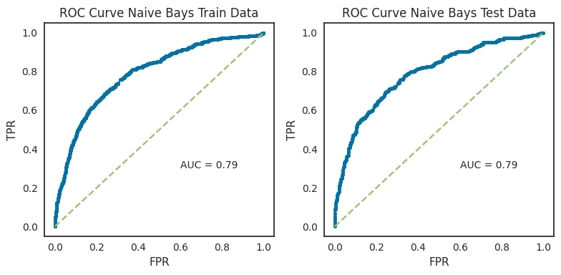

Fig ROC-AUC Curve Naïve Bayes

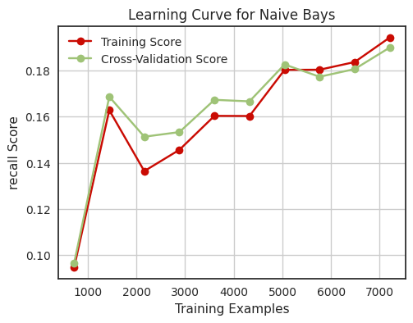

Fig Learning Curve Naïve Bayes

**Insights**

* The Naive Bayes model in the classification report is **not a good** model for predicting churn. It has a **low recall score on the train & test data (0.19 & 0.21 respectively)**
* The **model is overfitting** the training data, it is **not likely to generalize well to unseen data**.
* The above **model is not a good model for predicting churn**.

**Neural Network (ANN)**

ANNs are nonlinear statistical models which display a complex relationship between the inputs and outputs to discover a new pattern

Artificial Neural network is typically organized in layers. Layers are being made up of many interconnected ‘nodes’ which contain an ‘activation function’.

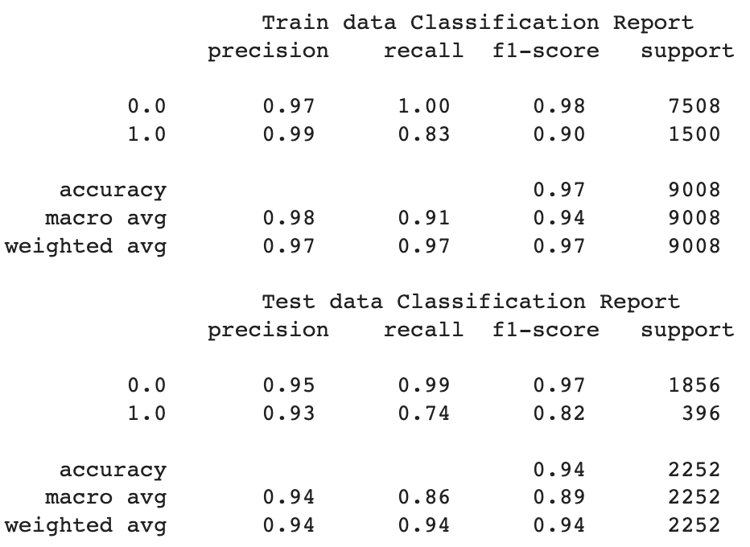

Table Classification report ANN

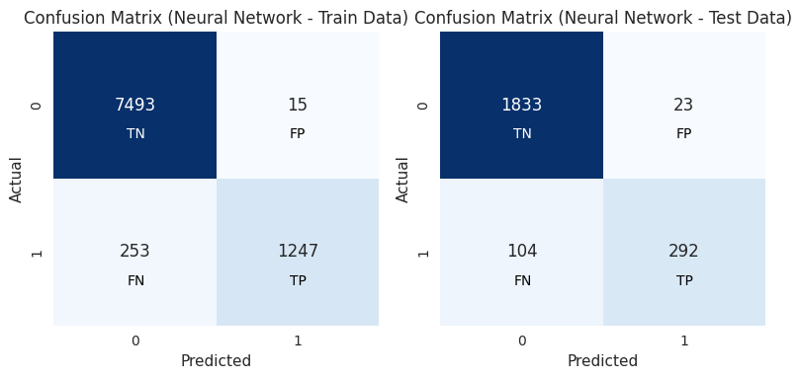

Fig Confusion Matrix ANN

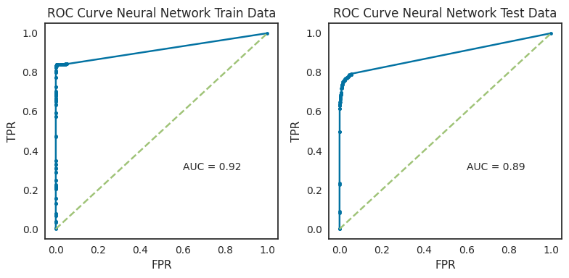

Fig ROC-AUC Curve ANN

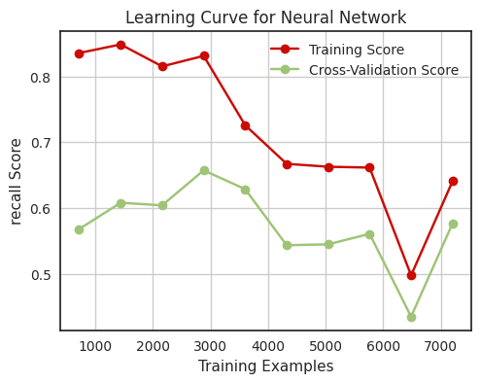

Fig Learning Curve ANN

**Insights**

* The ANN model has a comparatively lower recall score of **0.74 on** the test data for the minority class (churn) than few of previous models.
* The **model is overfitting** the training data and may not be able to generalize well to new data
* The model **may not be able to generalize well to new data**.

**Model Tuning**

**Ensemble methods & Hyperparameter Tuning**

Since most of the models are either overfitting or not giving a good recall score, we tried using Model Tuning to improve the performance.

A combination of ensemble methods and hyperparameter tuning can lead to highly accurate and robust machine learning models.

**Tuned LDA**

The LDA model was tuned and the best parameters came as: **{'solver': 'lsqr', 'tol': 0.1}**

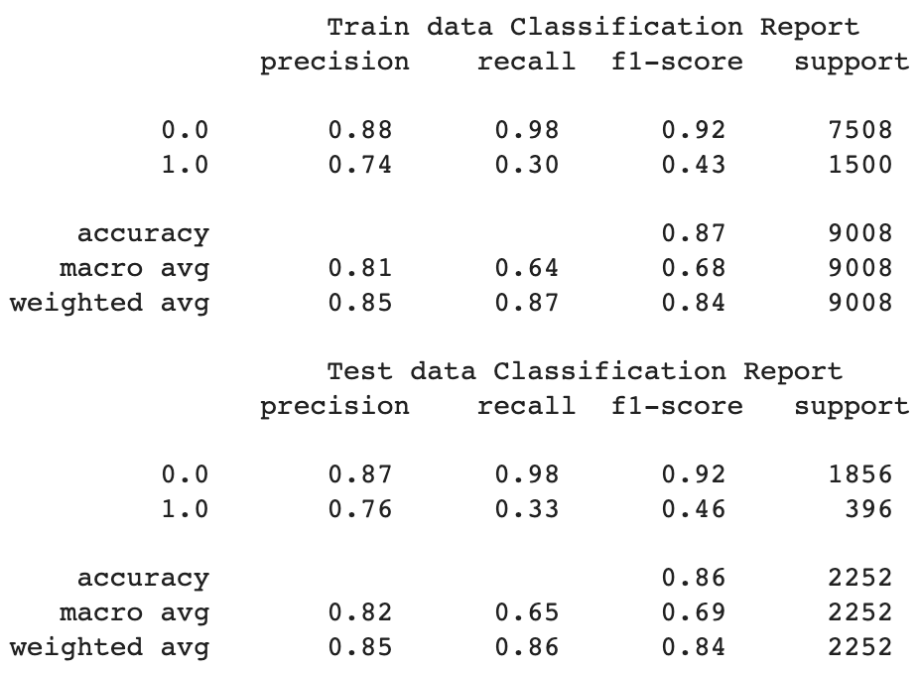

Table Classification report Tuned LDA

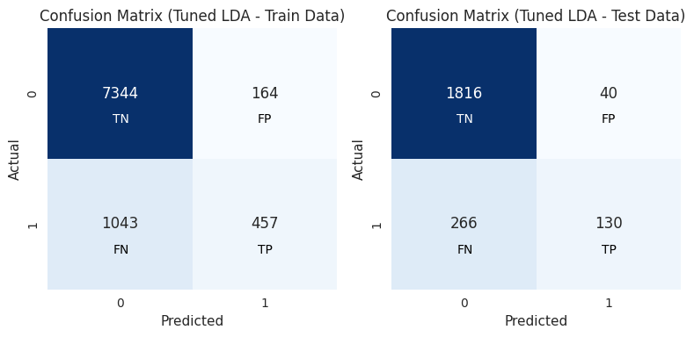

Fig Confusion Matrix Tuned LDA

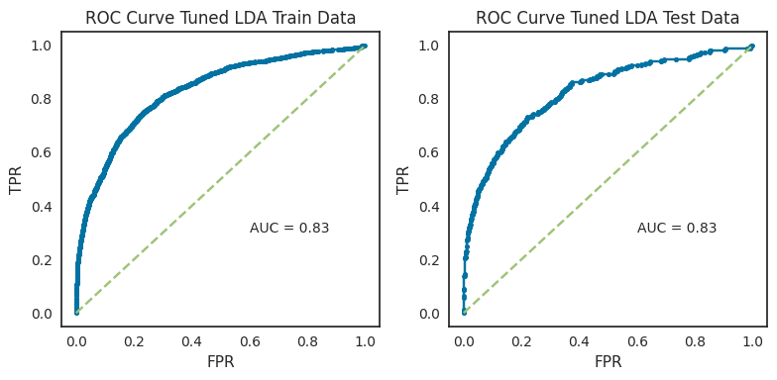

Fig ROC-AUC Curve Tuned LDA

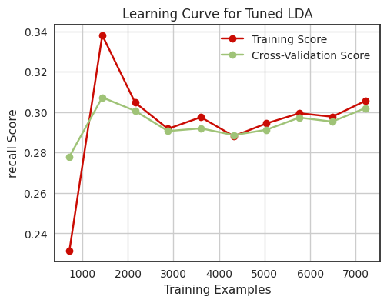

Fig Learning Curve Tuned LDA

**Insights**

* The Tuned LDA model **still has a poor recall score of 0.33** on the test data for the minority class (churn).
* The cross-validation scores are also very low, with a mean score of 0.302, which confirms that the **model is overfitting the training data**.
* The area under curve of 0.83 on both the training and test data is misleading in this case, as it is not a reliable measure of model performance when the class is imbalanced.
* There is **no improvement in LDA post tuning**. This might be due to imbalance dataset, since the tree models shows better performance, we will hyper tune /ensemble them. If none of them works well, we will try balancing data by oversampling data as last resort.

**Regularised Decision Tree**

The Decision Tree model was regularized and the best parameters came as :

Best max_depth: 12

Best min_samples_split: 2

Best min_samples_leaf: 1

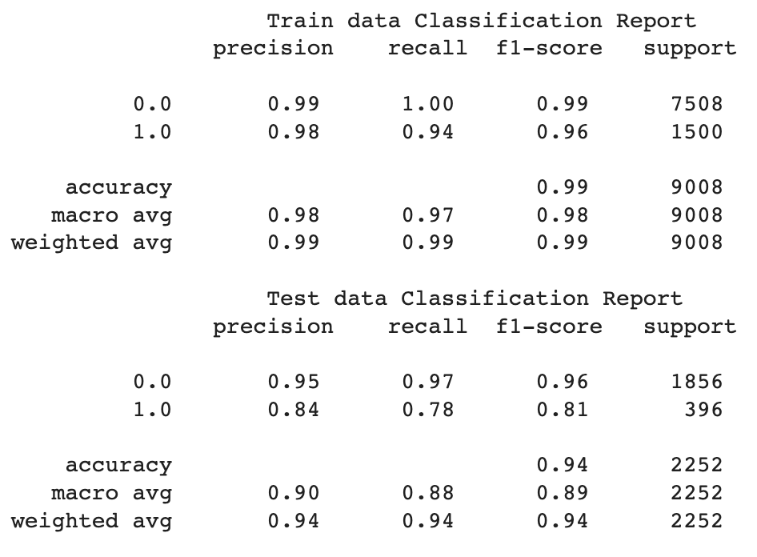

Table Classification report Regularised Decision Tree

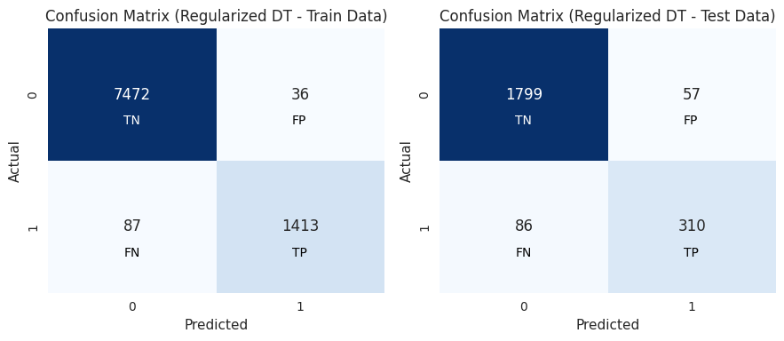

Fig Confusion Matrix Regularised Decision Tree

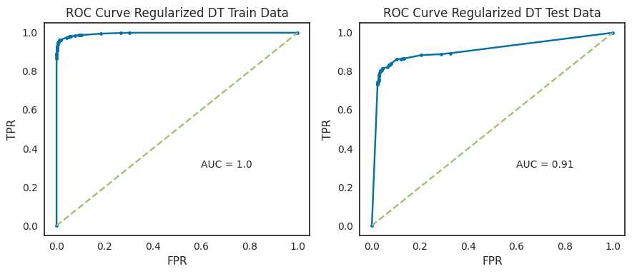

Fig ROC-AUC Curve Regularised Decision Tree

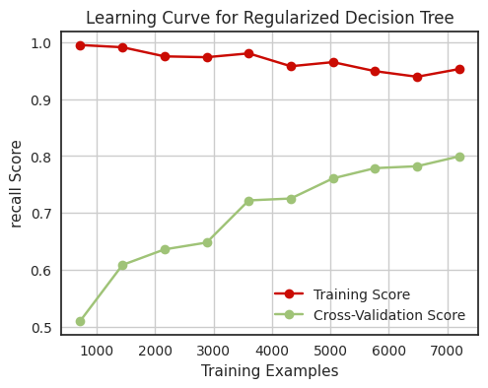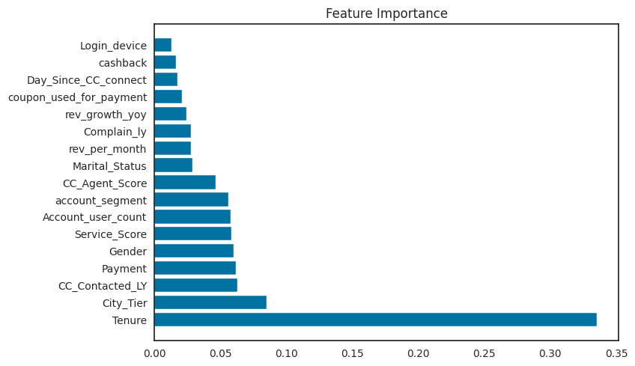

Fig Learning Curve Regularized Decision Tree Fig Feature importance Regularized Decision Tree

**Insights**

* The model is **able to identify a moderate proportion of the actual positive cases** (**78% recall** for the minority class).
* The **model is overfitting the training data**. This is evident from the large gap between the cross-validation scores and the training accuracy.
* The model **may not generalize well to new data**. This is evident from the plateau in the learning curve.
* Overall, the **regularized decision tree model is performing moderately** on the test set, with a **moderate recall for the minority** **class** and **overfitting**.

**Bagging**

Bagging also known as bootstrap aggregation is an ensemble technique that trains multiple complex

models (overfit models) in parallel and tries to smooth out their predictions by aggregating.

For Bagging, We have used the regularized decision Tree as base estimator.

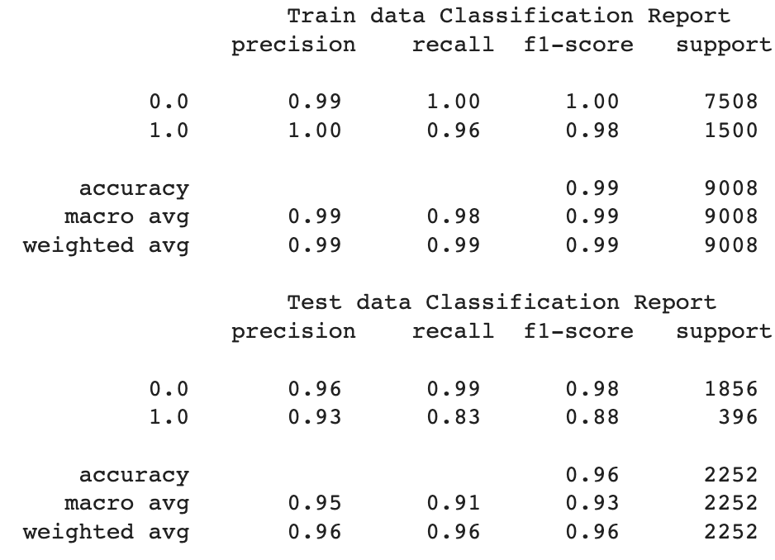

Table Classification report Bagging

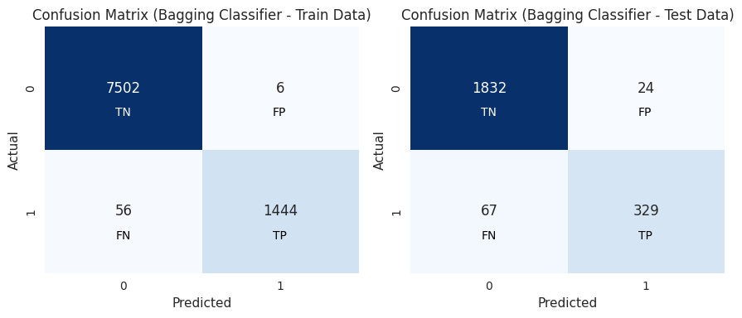

Fig Confusion Matrix Bagging

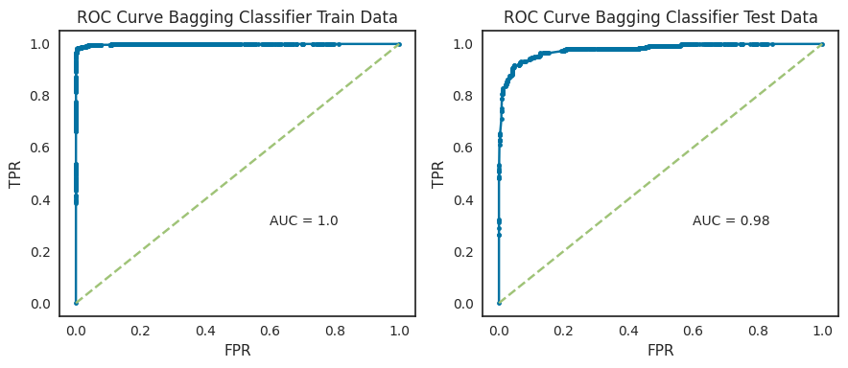

Fig ROC-AUC Curve Bagging

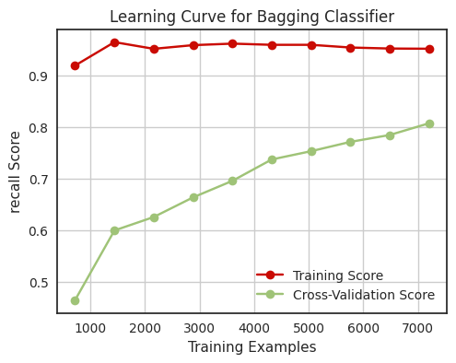

Fig Learning Curve Bagging

**Insights**

* The model is **able to identify a good proportion of the actual positive cases** (**83% recall for the minority class**). This may be sufficient for some applications, but it may not be sufficient for applications where it is critical to avoid false negatives.
* The **model is overfitting the training data**. This is evident from the large gap between the cross-validation scores and the training accuracy.
* The model **may not generalize well to new data**. This is evident from the plateau in the learning curve.
* Overall, the **bagging classifier is performing moderately on the test set**, with a **fair recall** for the minority class and **overfitting**.

**Random Forest with Tuning**

We built a random forest classifier, & search for the best fit model, using Grid Search Cross Validation Technique with the following values:

'max_depth': [4, 5, 6, 7]

'max_features': [1, 2, 3]

'min_samples_leaf': [1, 2, 3]

'min_samples_split': [6, 8, 10]

'n_estimators': [101, 301, 501]

We obtain the **best fit model** with the parameters:

'class_weight': 'balanced'

'max_depth': 7

'max_features': 3

'min_samples_leaf': 1

'min_samples_split': 8

'n_estimators': 301

The best fit model parameters are then used for creating a random forest classifier model &

predicting the train & test labels based on the independent variable values. The performance of the

model on the train & test set are as follows:

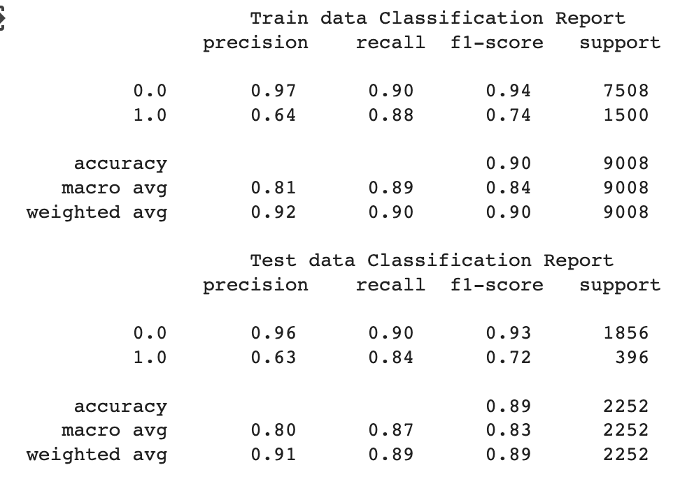

Table Classification report Tuned Random Forest

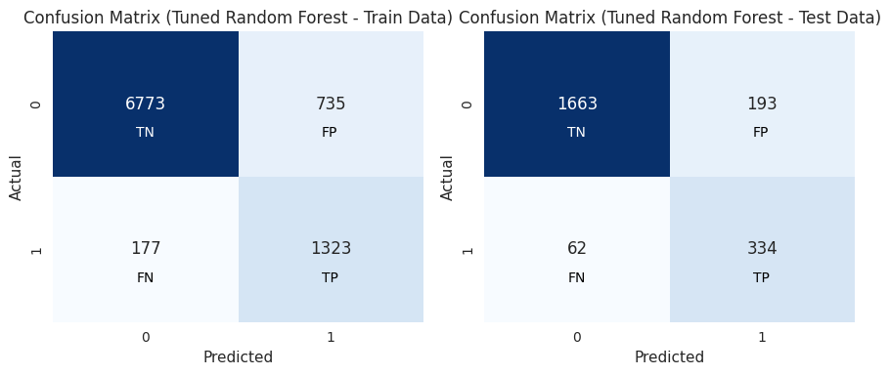

Fig Confusion Matrix Tuned Random Forest

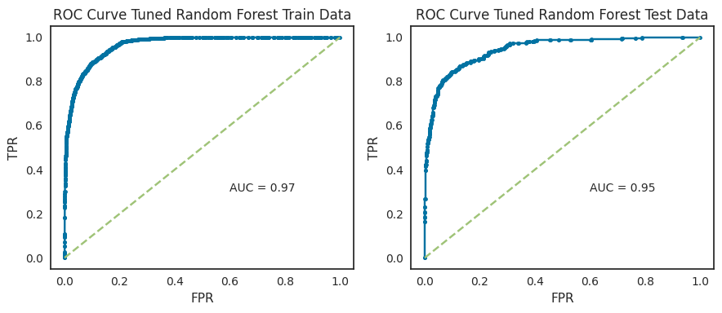

Fig ROC-AUC Curve Tuned Random Forest

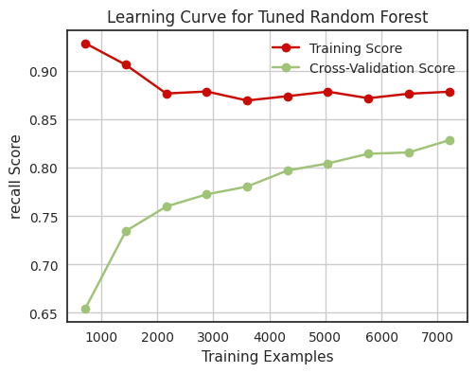 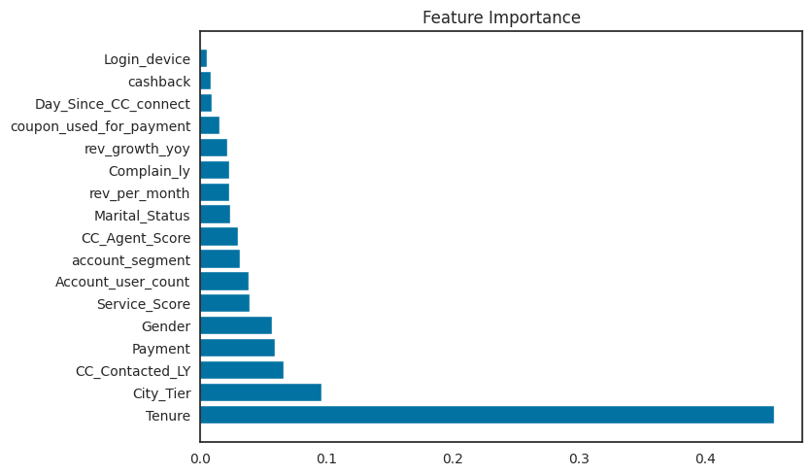

Fig Learning Curve Tuned Random Forest Fig Feature importance Tuned Random Forest

**Insights**

* The model is able to identify a **good proportion of the actual positive cases** (**88% recall for the minority class**). This may be sufficient for some applications, but it may not be sufficient for applications where it is critical to avoid false negatives.
* The model is **slightly overfitting the training data**. However, the overfitting is not severe and the model is still able to generalize well to new data.
* The most important Features are **Tenue, City Tier and CC_Contacted_LY** for the model

**Adaboost**

Boosting trains, a large number of simple models (weak/ underfitting models) in sequence &

combines them into a single strong model. The Training data remains the same during the creation

of successive models only weights are added to the misclassified datapoints of the previous model

& reduced for the correctly classified datapoints of the previous model.

We build an **adaptive boosting classifier** using the **regularized decision as base estimator** & search

for the appropriate number of simple models using the Grid Search Cross Validation Technique:

No. of estimators: 301, CV=10, Scoring = ‘recall’

We then create an adaptive boosting classifier model & predict the train & test labels based on the

independent variable values. The performance of the model on the train & test set are as follows:

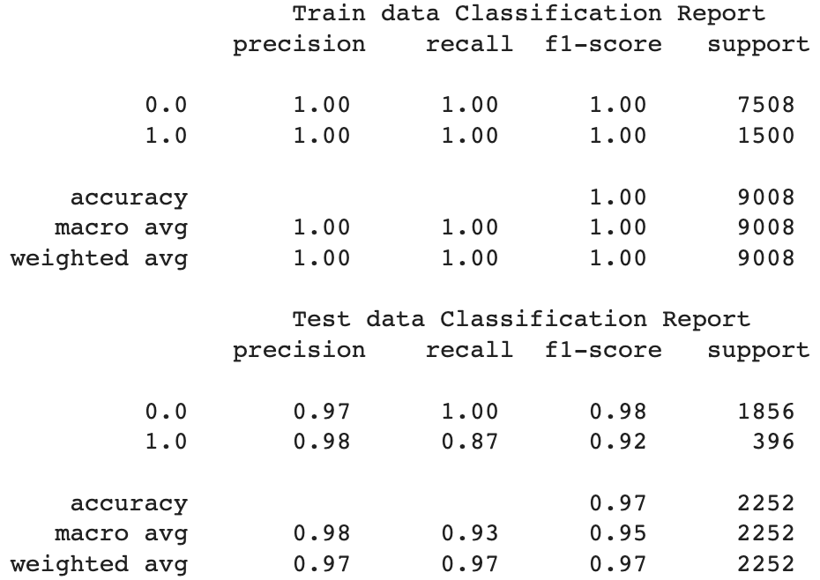

Table Classification report Adaboost

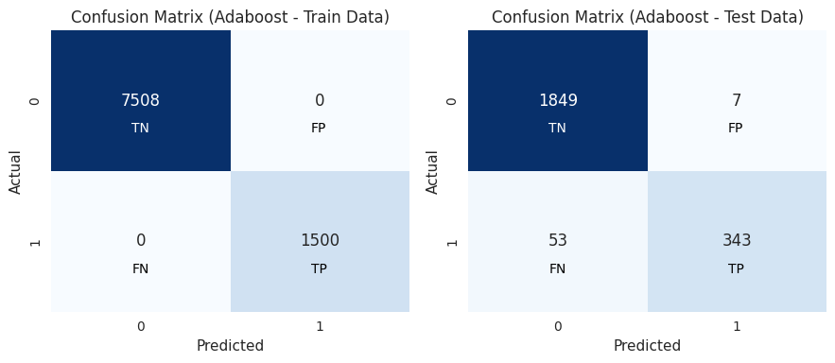

Fig Confusion Matrix Adaboost

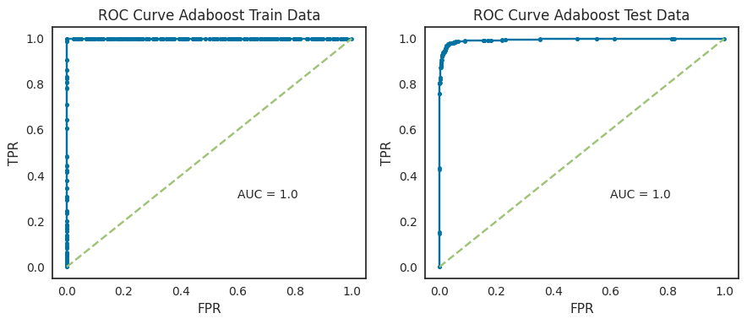

Fig ROC-AUC Curve Adaboost

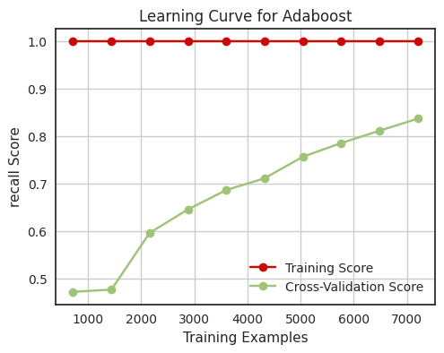 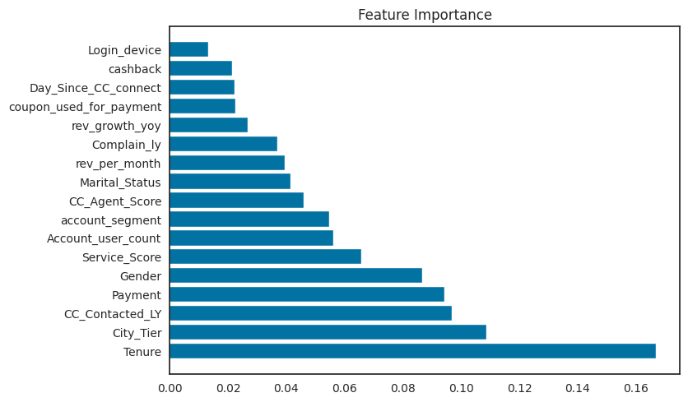

Fig Learning Curve Adaboost Fig Feature importance Adaboost

**Insights**

* The model is able to identify a **good proportion of the actual positive cases** (**87% recall for the minority class**).
* The model is **slightly overfitting the training data**. However, the overfitting is not severe and the model is still able to generalize well to new data.
* The AUC is 100% for both test & train, however, would not be the accurate representation
* The most important Features are **Tenue, City Tier and CC_Contacted_LY** for the model

**XG Boost with Hyperparameter Tuning**

Xtreme Gradient Boosting is an ensemble technique that uses an ensemble of decision trees and

gradient boosting to make predictions. We build a XGBoost classifier & search for the best fit model, using Grid Search Cross Validation Technique with the following values:

*'learning_rate': [0.2, 0.1, 0.05],*

*'max_depth': [6, 8, 10],*

*'colsample_bytree': [0.9, 0.8, 0.7],*

*'colsample_bynode': [1, 0.9],*

*'colsample_bylevel': [0.9, 0.8],*

*'scale_pos_weight': [0.2, 0.4],*

*'subsample': [0.9, 0.8, 0.7],*

*'gamma': [0, 0.5, 1],*

The best fit parameters came as :

*{'colsample_bylevel': 0.8, 'colsample_bynode': 1,*

*'colsample_bytree': 0.9, 'gamma': 0,*

*'learning_rate': 0.2, 'max_depth': 10,*

*'scale_pos_weight': 0.4, 'subsample': 0.9}*

The best fit model parameters are then used for creating a XG Boost classifier model & predicting

the train & test labels based on the independent variable values. The performance of the model on

the train & test set are as follows: -

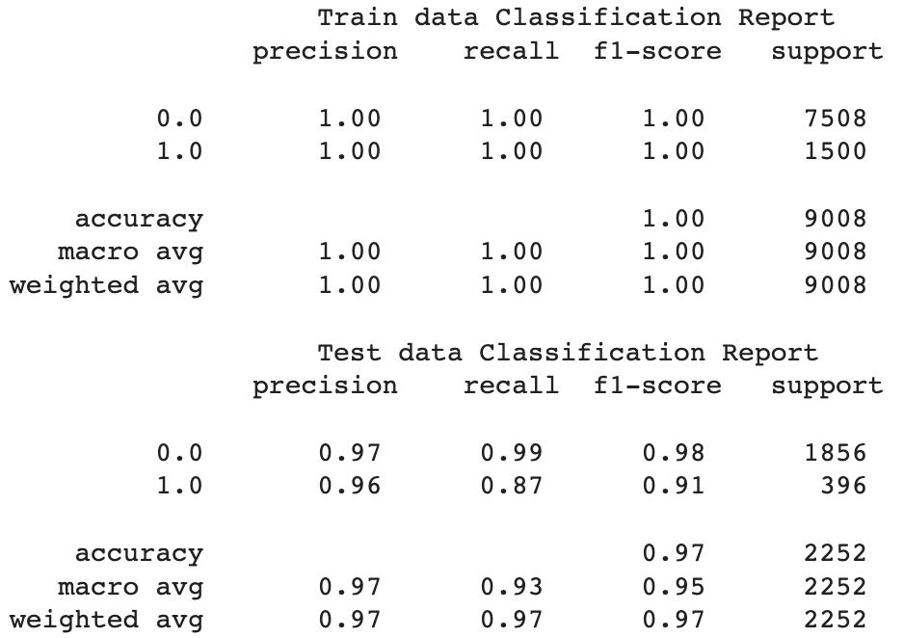

Table Classification report XGBoost

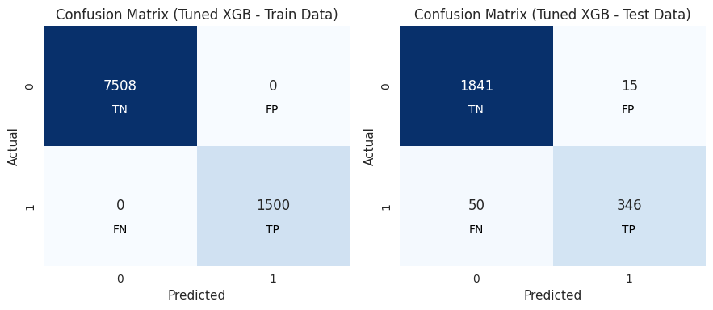

Fig Confusion Matrix XGBoost

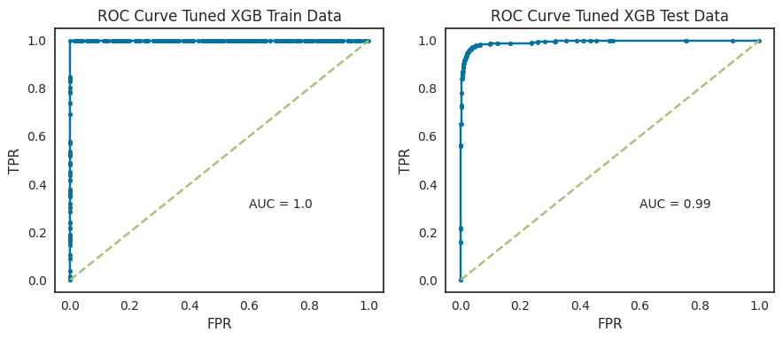

Fig ROC-AUC Curve XGBoost

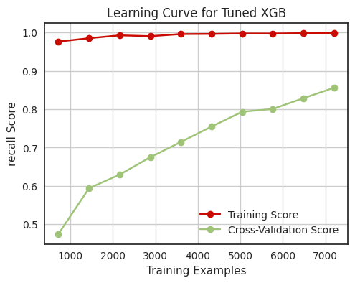 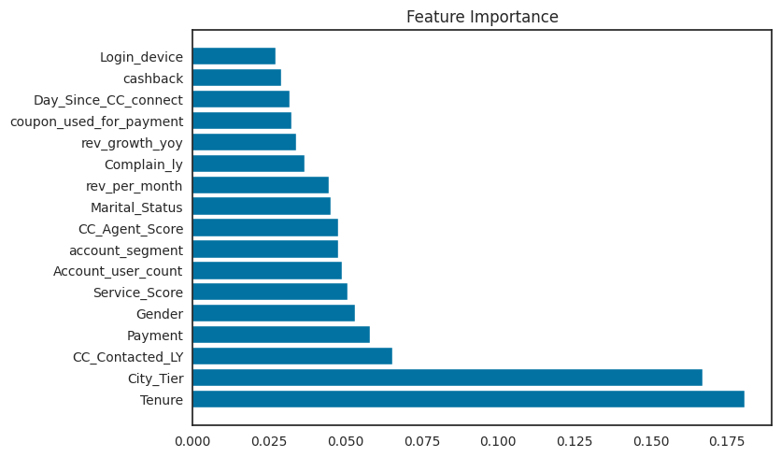

Fig Learning Curve XGBoost Fig Feature importance XGBoost

**Insights**

* The model is **able to identify 87% of the actual positive cases** (**recall** of minority class). This is a good result, but it could be improved.
* The **model is overfitting** the training data. This is evident from the cross-validation scores and the learning curve.
* The model is performing well on the test set, with an **accuracy of 97%.** This suggests that the **model is able to generalize to new data**.
* The most important Features are **Tenue, City Tier and CC_Contacted_LY** for the model
* There is room for improvement in the model performance, especially in terms of recall of minority class and overfitting.

**CatBoost with Hyperparameter Tuning**

Catboost (or Categorical Boosting) is a variant of gradient boosting that can handle both categorical and numerical features. It is especially powerful in two ways:

* It yields state-of-the-art results without extensive data training typically required by other machine learning methods, and
* Provides powerful out-of-the-box support for the more descriptive data formats that accompany many business problems.

While Catboost can work on categorical data without need of encoding, however, we used encoded data here. We build a CatBoost classifier & search for the best fit model, using Grid Search Cross

Validation Technique with the following values:

*'depth': [6, 8, 10],*

*'learning_rate': [0.1, 0.05, 0.01],*

*'iterations': [100, 200, 300],*

*'l2_leaf_reg': [3, 5, 7],*

We obtain the **best fit** model with the parameters:

*'depth': 10,*

*'iterations': 300,*

*'l2_leaf_reg': 3,*

*'learning_rate': 0.1}*

The best fit model parameters are then used for creating a Cat Boost classifier model & predicting

the train & test labels based on the independent variable values. The performance of the model on

the train & test set are as follows: -

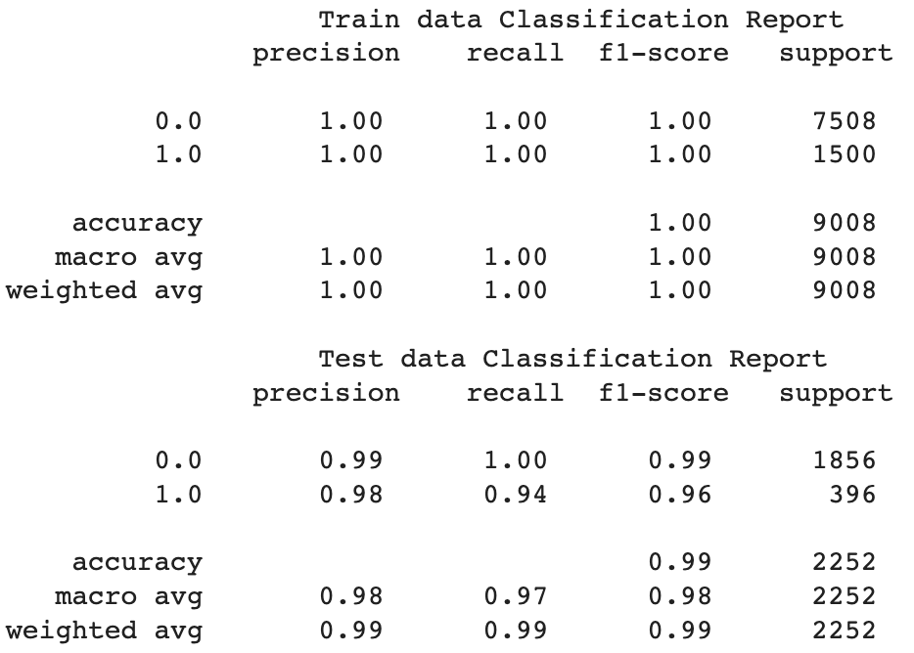

Table Classification report CatBoost

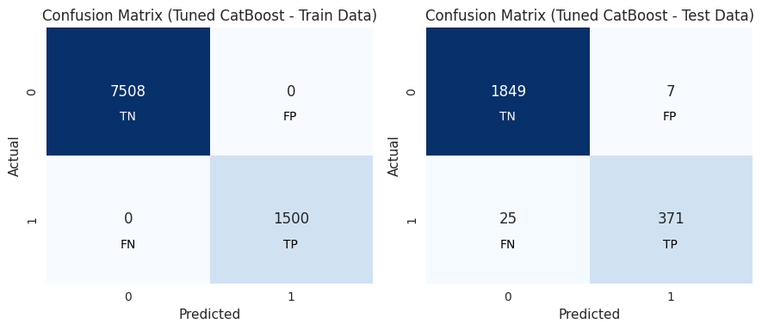

Fig Confusion Matrix CatBoost

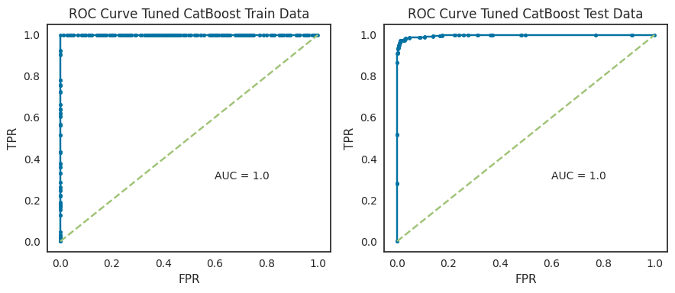

Fig ROC-AUC Curve CatBoost

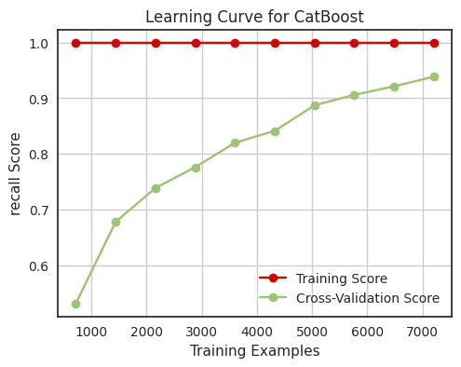 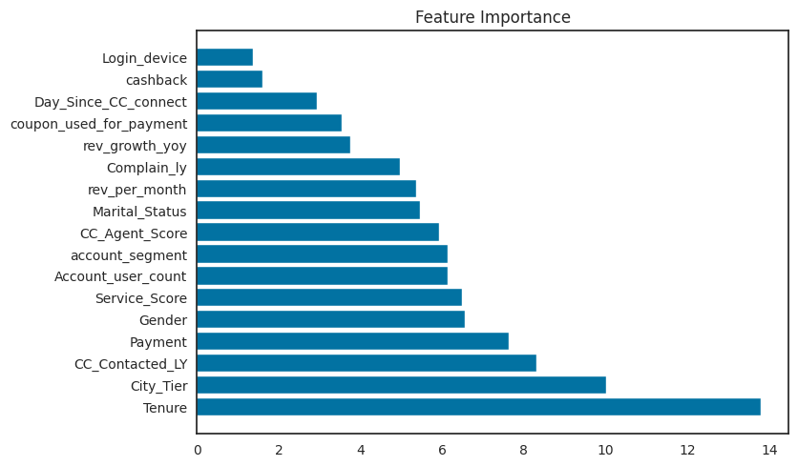

Fig Learning Curve CatBoost Fig Feature importance CatBoost

**Insights**

* The model is **able to identify a large proportion of the actual positive cases** (**94% recall for the minority class**). This is so far the best model results we are able to get.
* The model is **not severely overfitting the training data**. This is evident from the relatively small difference between the training accuracy and the cross-validation score.
* The **model is able to generalize well to new data**. This is evident from the high plateau in the learning curve.
* The most important Features are **Tenue, City Tier and CC_Contacted_LY** for the model

**Model Evaluation Parameters**

When it comes to model validation of a classification problem statement we cannot just get relied on accuracy, we need to look at various others parameter like F1 score, Recall, precision, ROC curve and AUC score, along with confusion matrix. The details of these parameters are described below: -

**Confusion Matrix:**

Confusion Matrix usually causes a lot of confusion even in those who are using them regularly. Terms used in defining a confusion matrix are TP, TN, FP, and FN.

**True Positive (TP): -** The actual is positive in real and at the same time the prediction was classified correctly.

**False Positive (FP): -** The actual was actually negative but was falsely classified as positive.

**True Negative: -** The actuals were actually negative and was also classified as negative which is the right thing to do.

**False Negative: -** The actuals were actually positive but was falsely classified as negative.

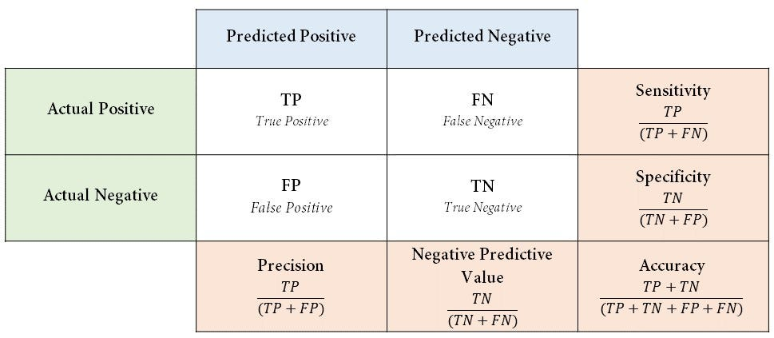

**Various Components Of Classification Report: -**

**Accuracy:** This term tells us how many right classifications were made out of all the classifications.

*Accuracy = (TP + TN) / (TP + FP +TN + FN)*

**Precision:** Out of all that were marked as positive, how many are actually truly positive.

*Precision = TP / (TP + FP)*

**Recall or Sensitivity:** Out of all the actual real positive cases, how many were identified as positive.

*Recall = TP/ (TN + FN)*

**Specificity:** Out of all the real negative cases, how many were identified as negative.

*Specificity = TN/ (TN + FP)*

**F1-Score:** As we saw above, sometimes we need to give weightage to FP and sometimes to FN. F1 score is a weighted average of Precision and Recall, which means there is equal importance given to FP and FN. This is a very useful metric compared to “Accuracy”. The problem with using accuracy is that if we have a highly imbalanced dataset for training (for example, a training dataset with 95% positive class and 5% negative class), the model will end up learning how to predict the positive class properly and will not learn how to

identify the negative class. But the model will still have very high accuracy in the test dataset too as it will know how to identify the positives really well.

*F1 score = 2* (Precision * Recall) / (Precision + Recall)*

**Area Under Curve (AUC) and ROC Curve:**

AUC or Area Under Curve is used in conjecture with ROC Curve which is Receiver Operating Characteristics Curve. AUC is the area under the ROC Curve. So, let’s first understand the ROC Curve. A ROC Curve is drawn by plotting TPR or True Positive Rate or Recall or Sensitivity (which we saw above) in the y-axis against FPR or False Positive Rate in the x-axis. FPR = 1- Specificity (which we saw above).

*TPR = TP/ (TP + FN)*

*FPR = 1 – TN/ (TN+FP) = FP/ (TN + FP)*

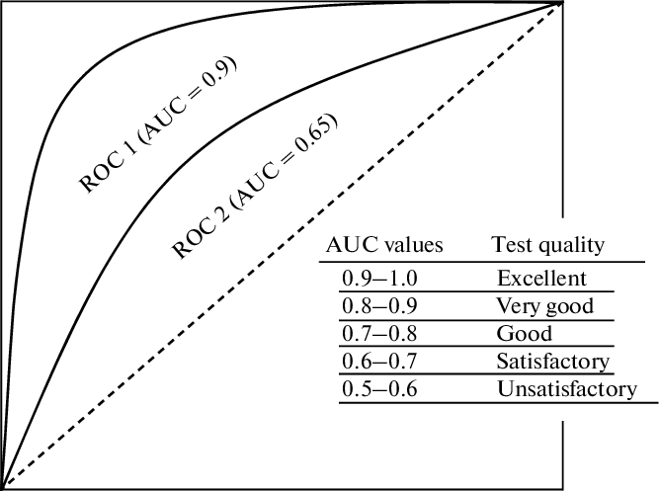

When we want to select the best model, we want a model that is closest to the perfect model. In other words, a model with AUC close to 1. When we say a model has a high AUC score, it means the model’s ability to separate the classes is very high (high separability). This is a very important metric that should be checked while selecting a classification model.

**Confusion Matrix of all models on Train data**

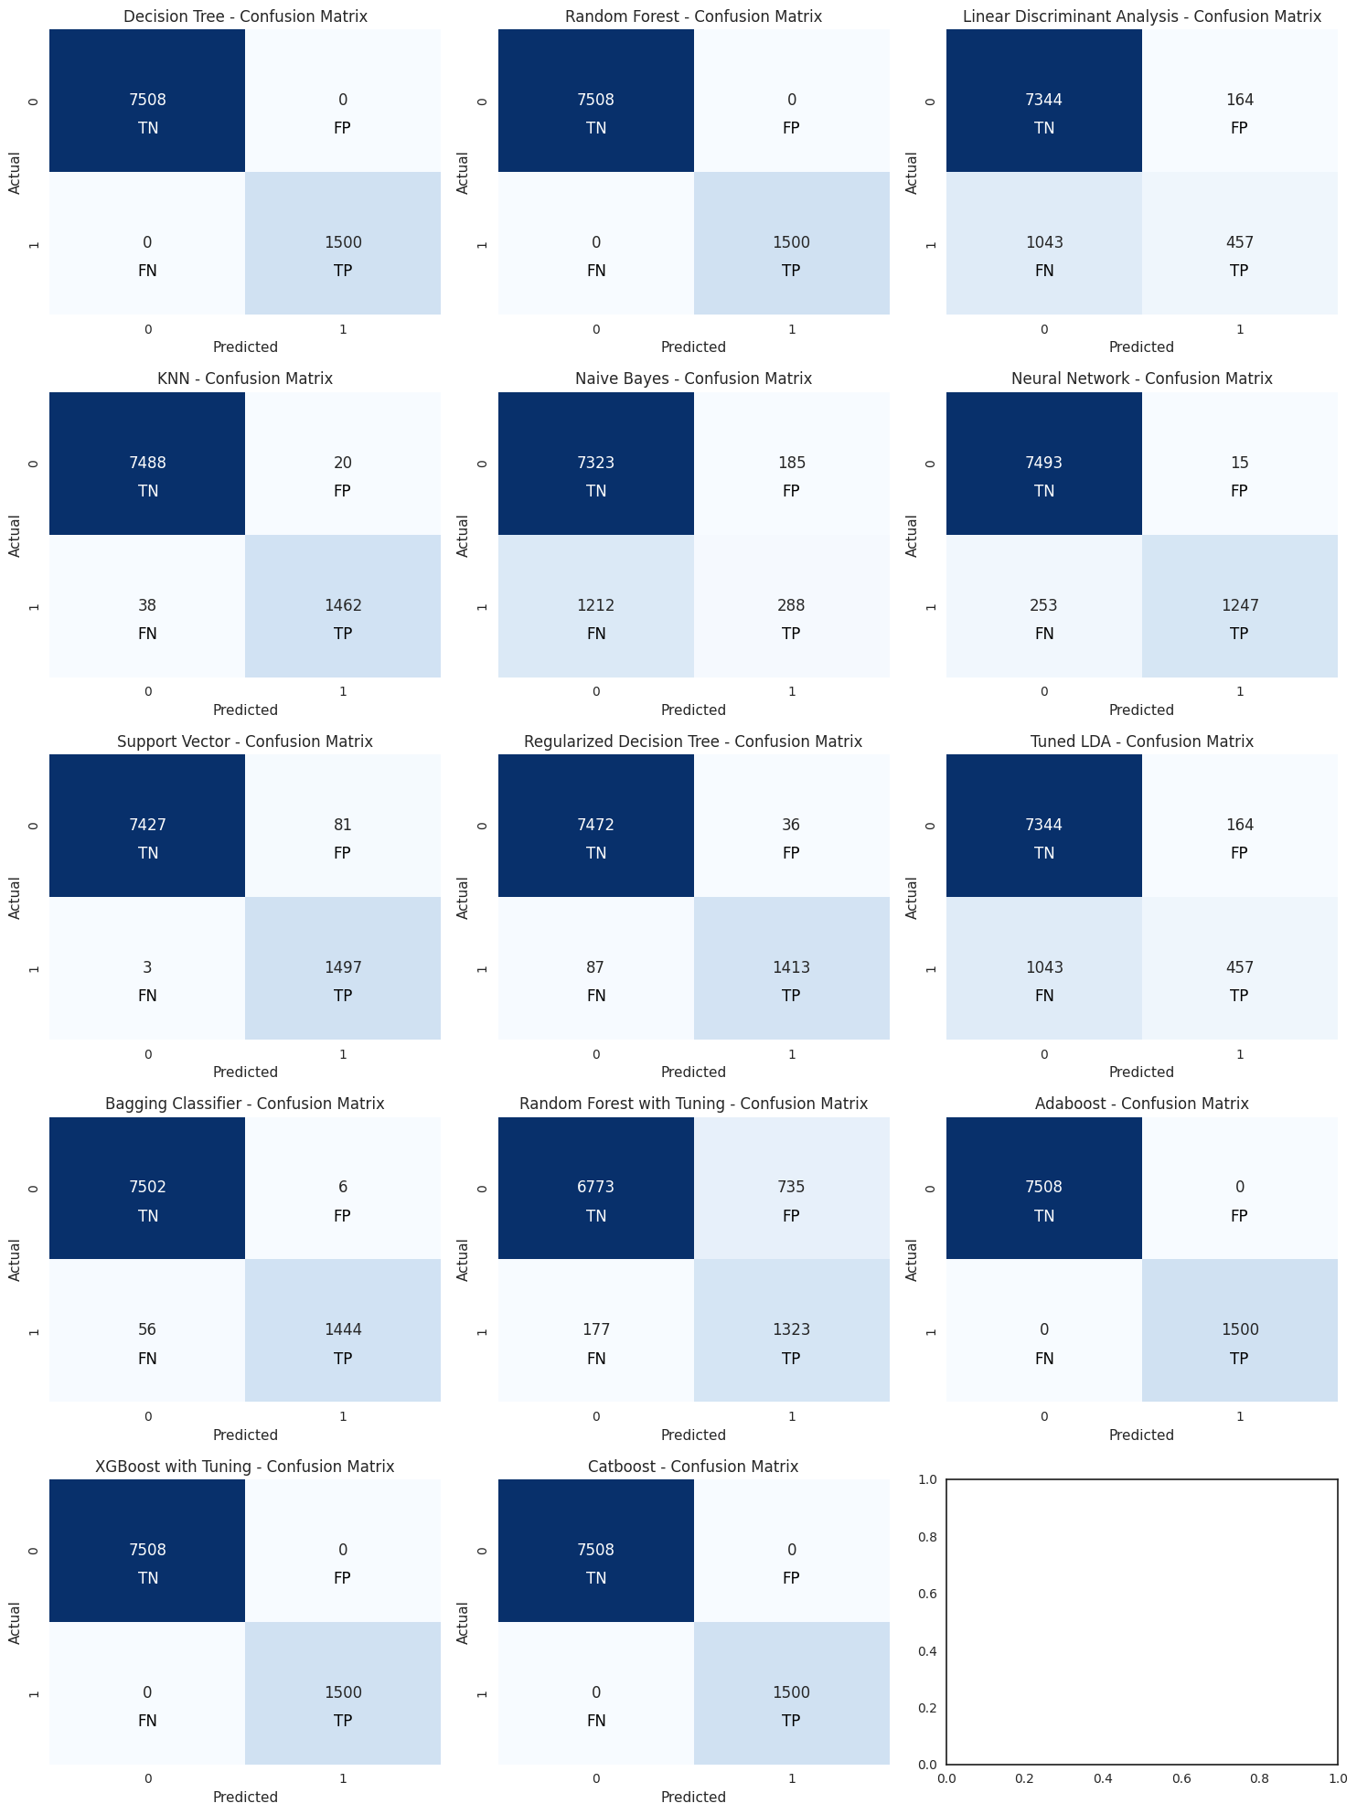





**Confusion Matrix of all models on Test data**

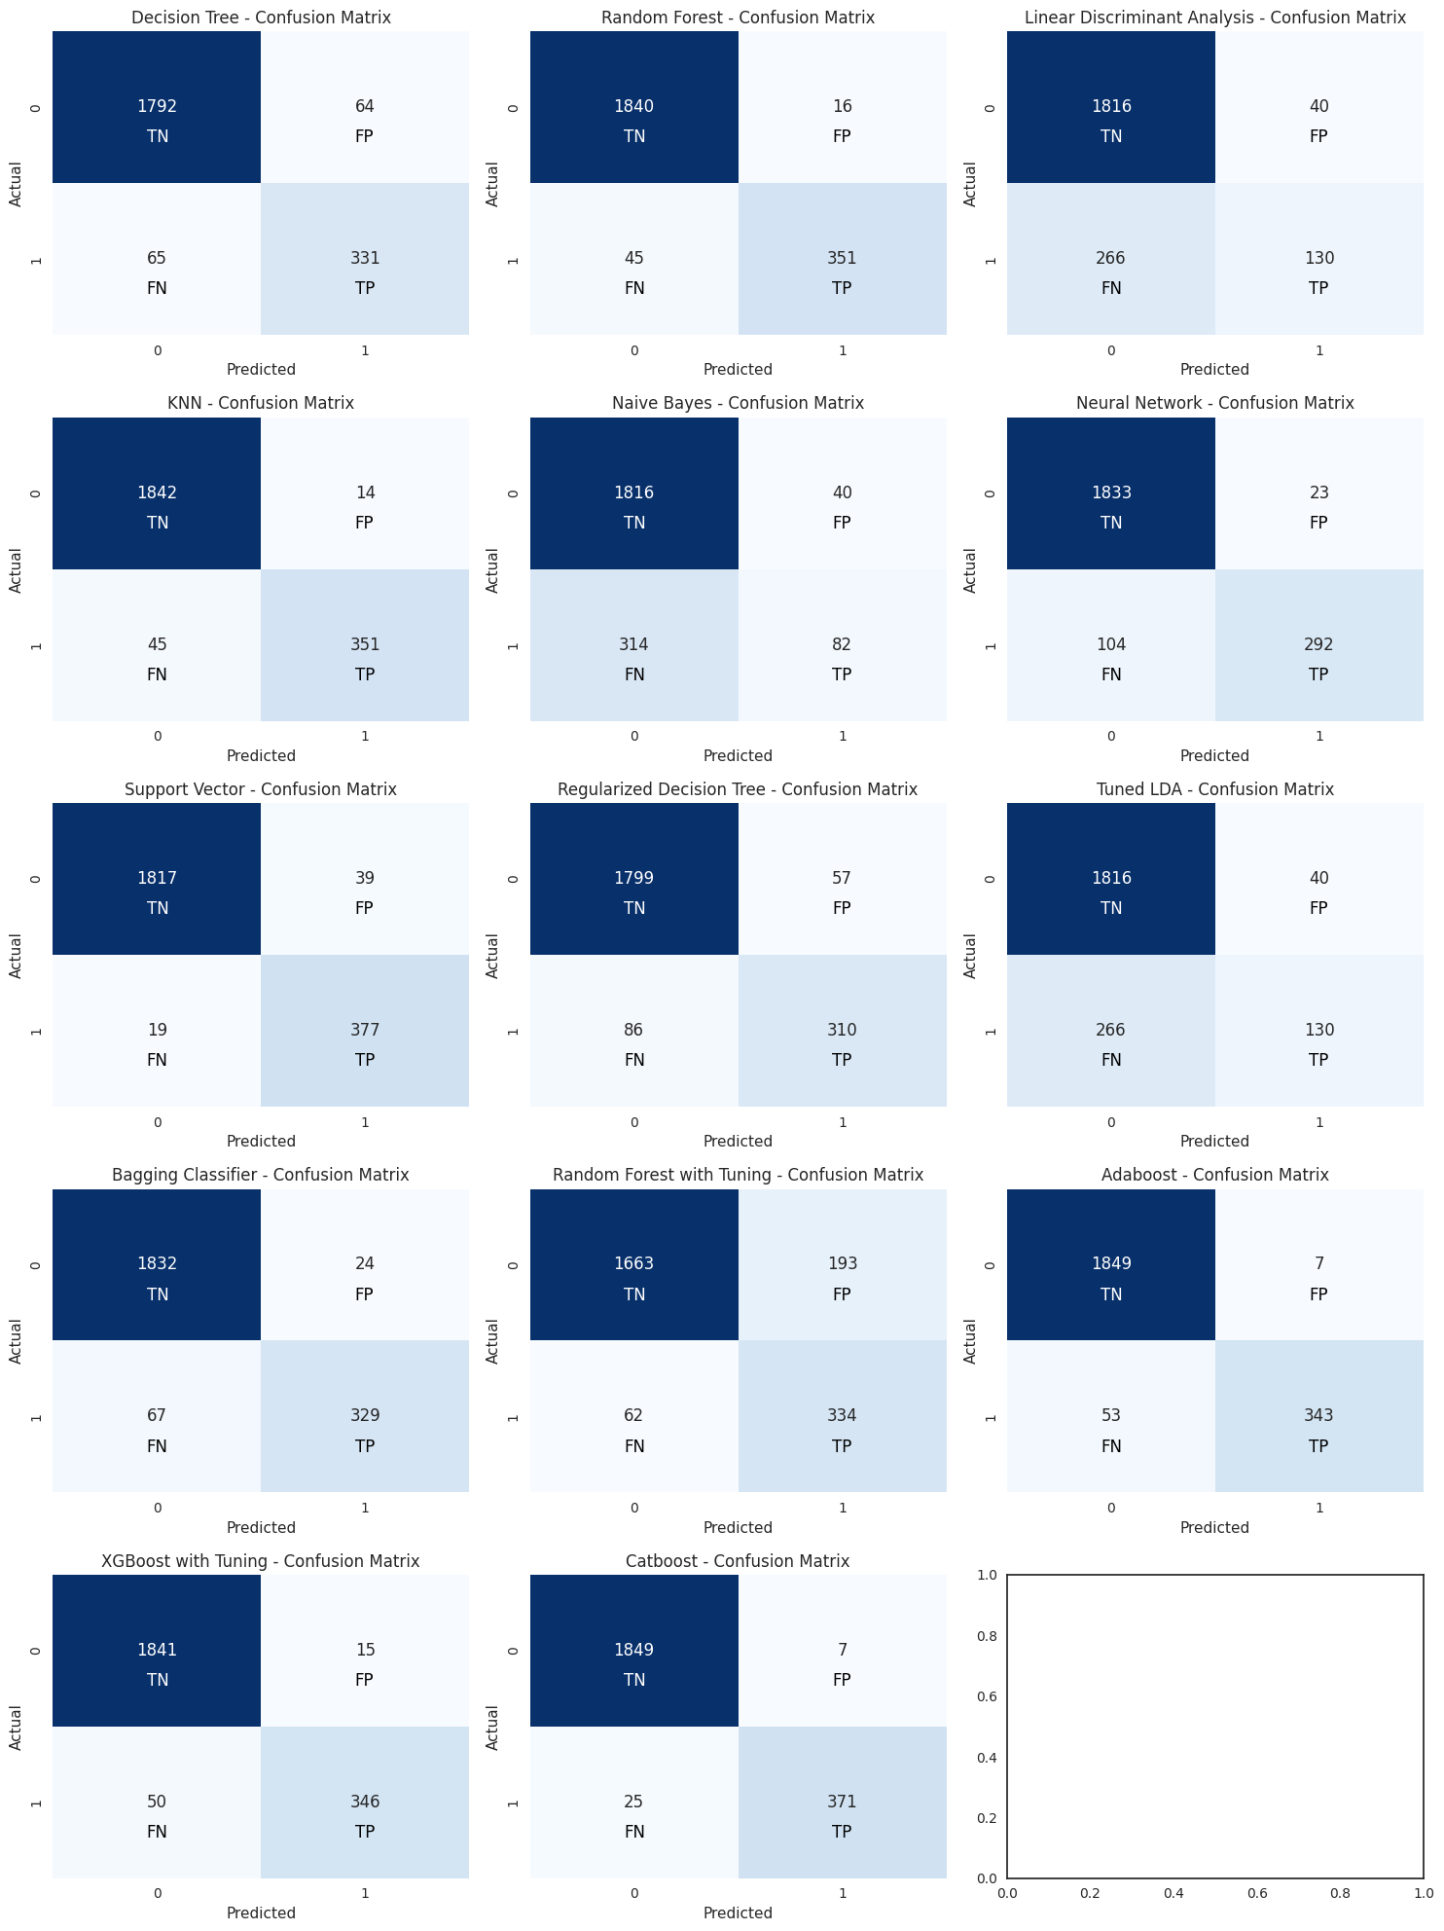





**Evaluation report of all models on Train & Test data**

